Assignment 10: Rest API / Triggers Assignment

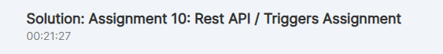

1. Create a pipeline to fetch the All countries data from Rest API (https://restcountries.com/v3.1/all) and save it as parquet file in ADLS.

Tricky:

2. Create a pipeline to fetch the 5 countries (india,us,uk,china,russia) data from Rest API (https://restcountries.com/v3.1/name/{name} here replace the {name} with Country name like https://restcountries.com/v3.1/name/us) and save it in separate file as JSON with File name equal to Country name.

3. Add the trigger to above pipeline in such a way that it will automatically run two times in a day ( 12:00 AM and 12:00 PM IST)

Tip: Incase you can't able to do Q2, do this on Q1

4. Now to make it more realistic, as soon as any copy activity fails in the above pipeline send an automated email to notify user.

5. Make the mail more generic by sending the Pipeline name, Stauts, SenderMailiD, and Name within the mail. Ensure mail will come in case of both success and Fail.

6. Once a file for India gets generated trigger a pipeline that will copy the India.json file as CSV into the ADLS account.

Solution 1 for Quesiton1:

1. Create a pipeline to fetch the All countries data from Rest API (https://restcountries.com/v3.1/all) and save it as parquet file in ADLS.

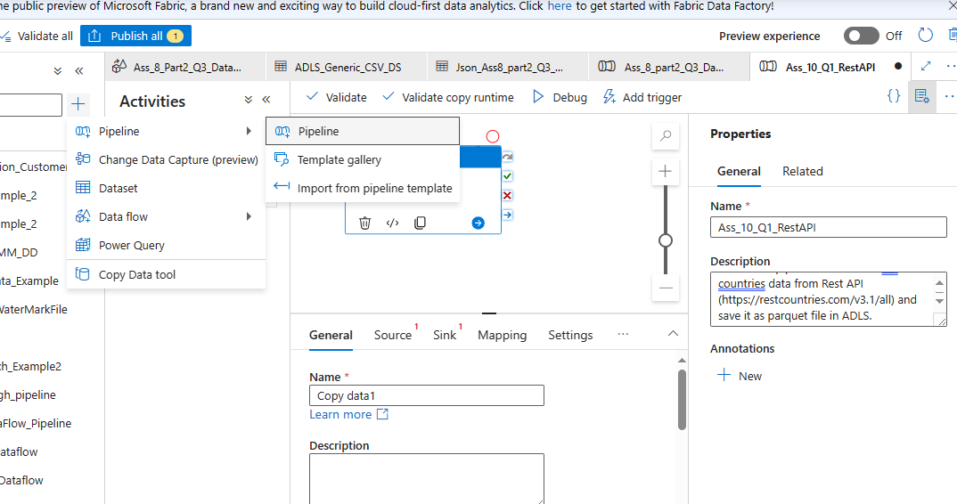

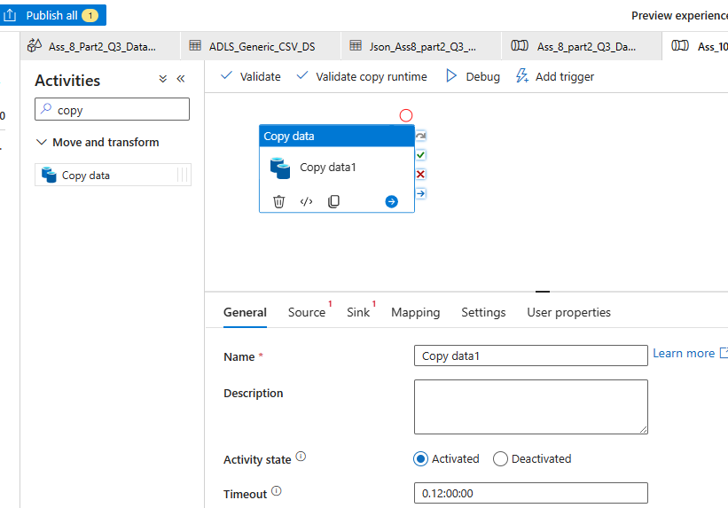

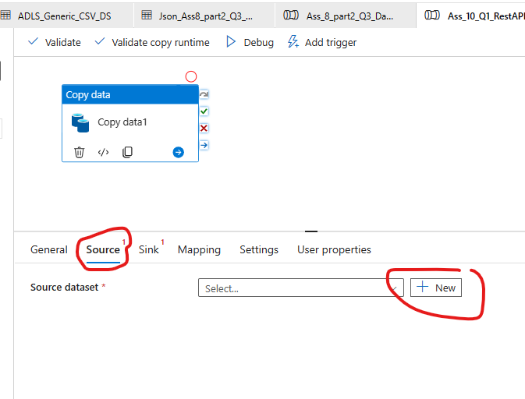

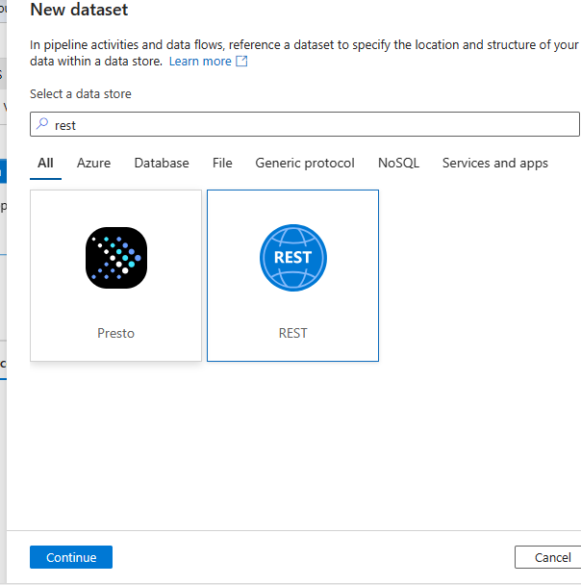

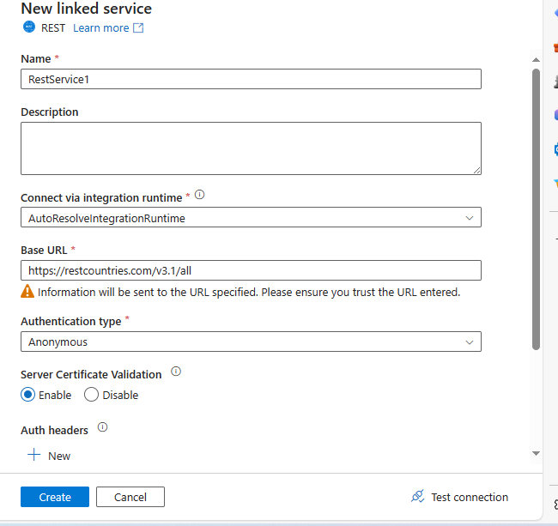

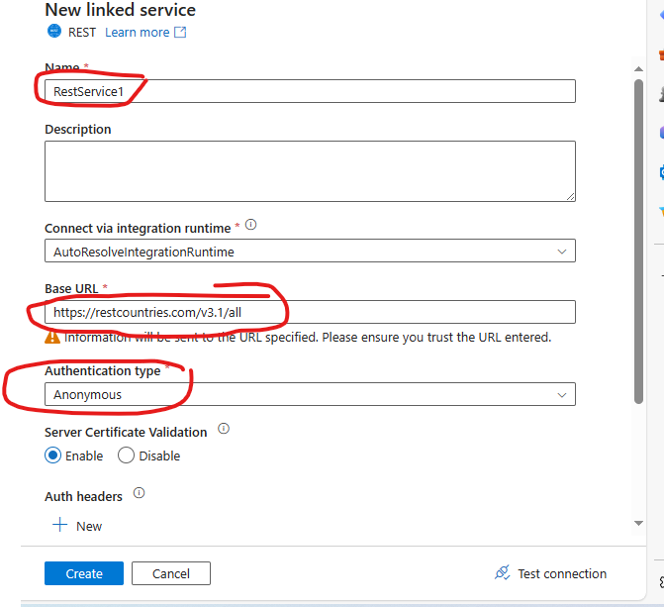

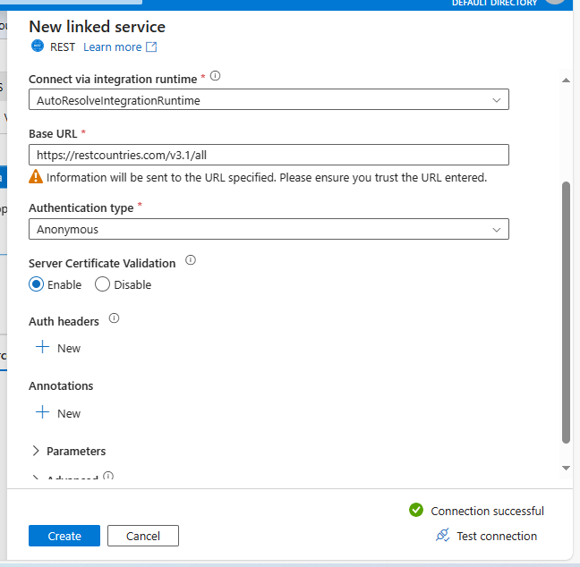

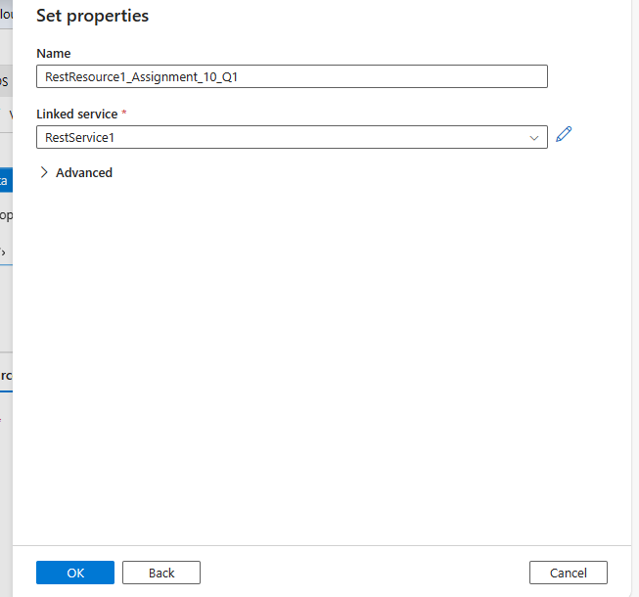

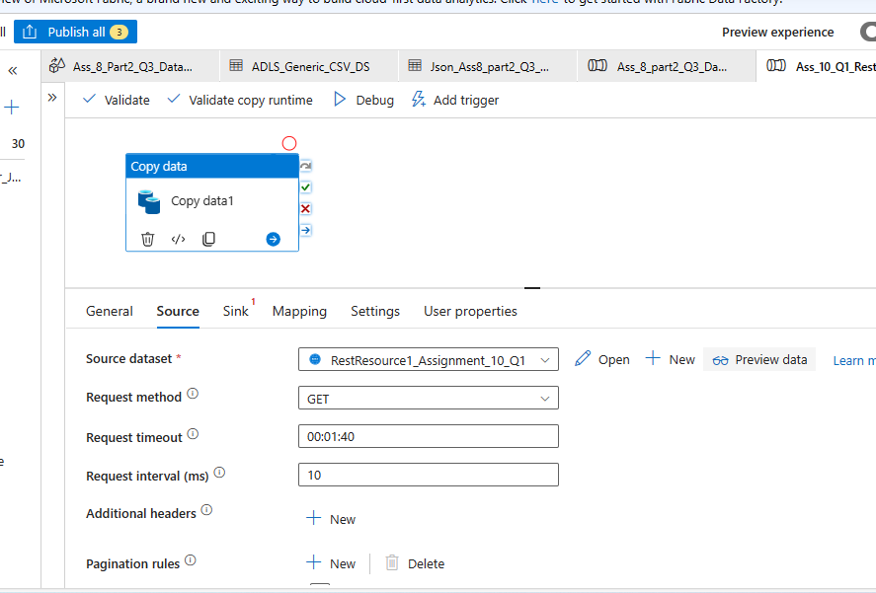

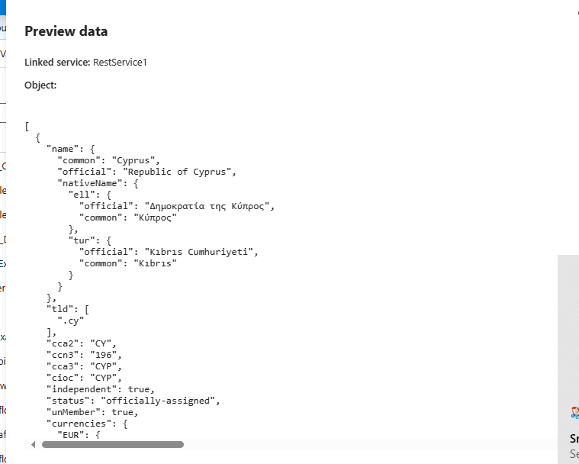

Select Sink as ADLS gen2 “Parquet” file type
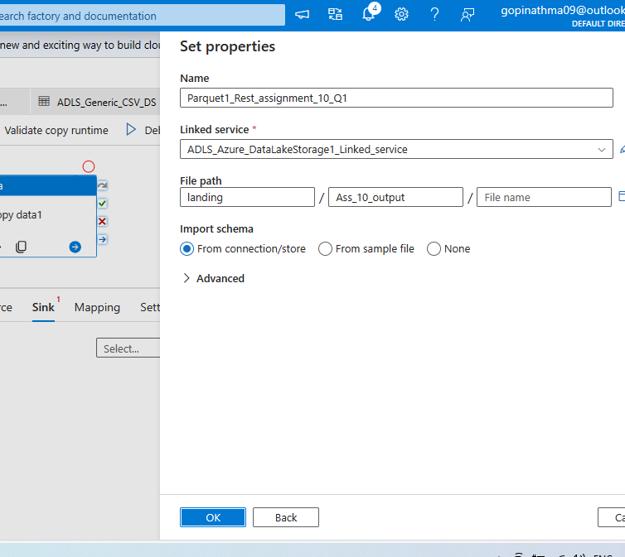

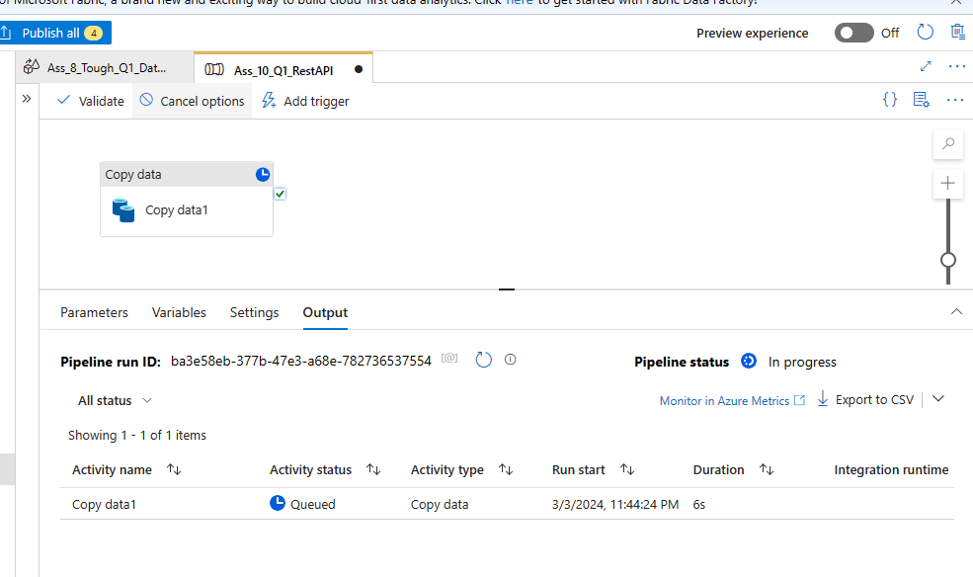

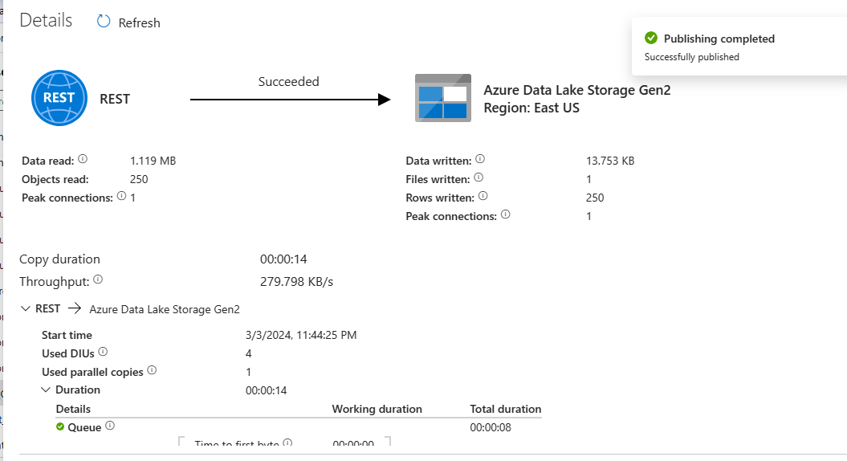

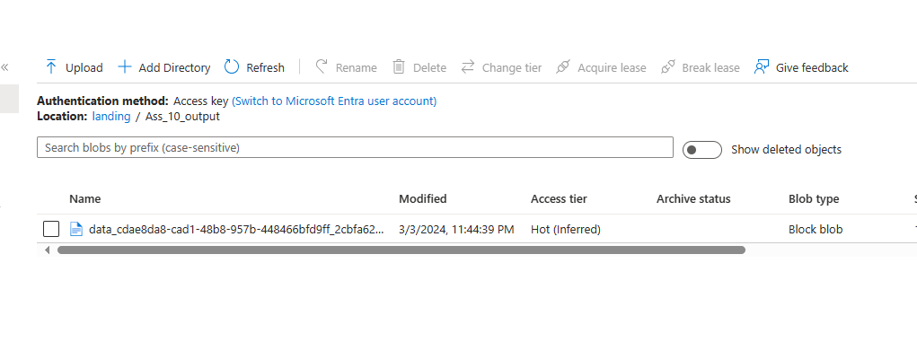

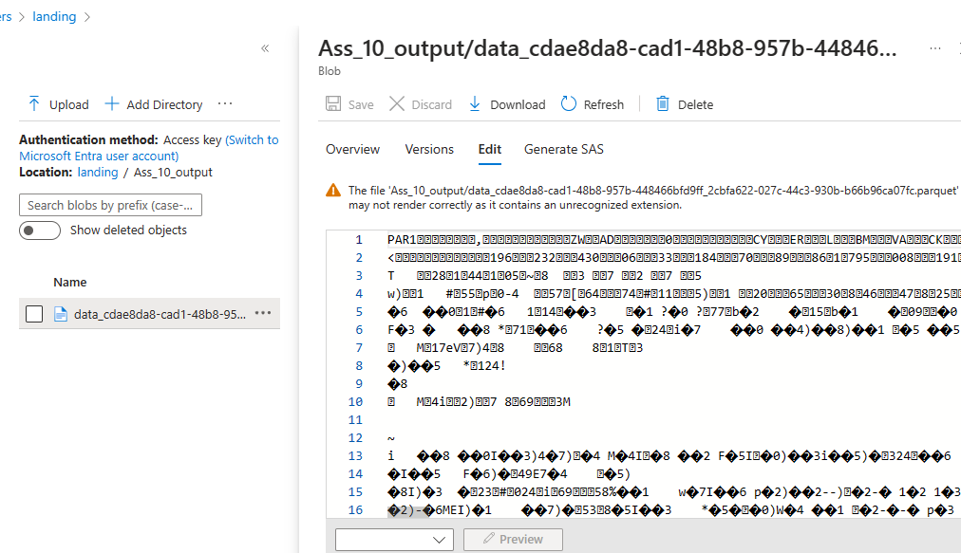

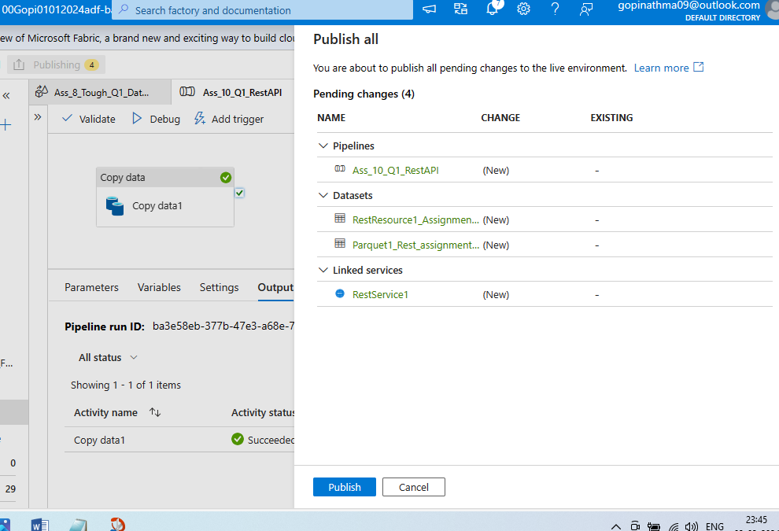

Question2:

2. Create a pipeline to fetch the 5 countries (india,us,uk,china,russia) data from Rest API (https://restcountries.com/v3.1/name/{name} here replace the {name} with Country name like https://restcountries.com/v3.1/name/us) and save it in separate file as JSON with File name equal to Country name.

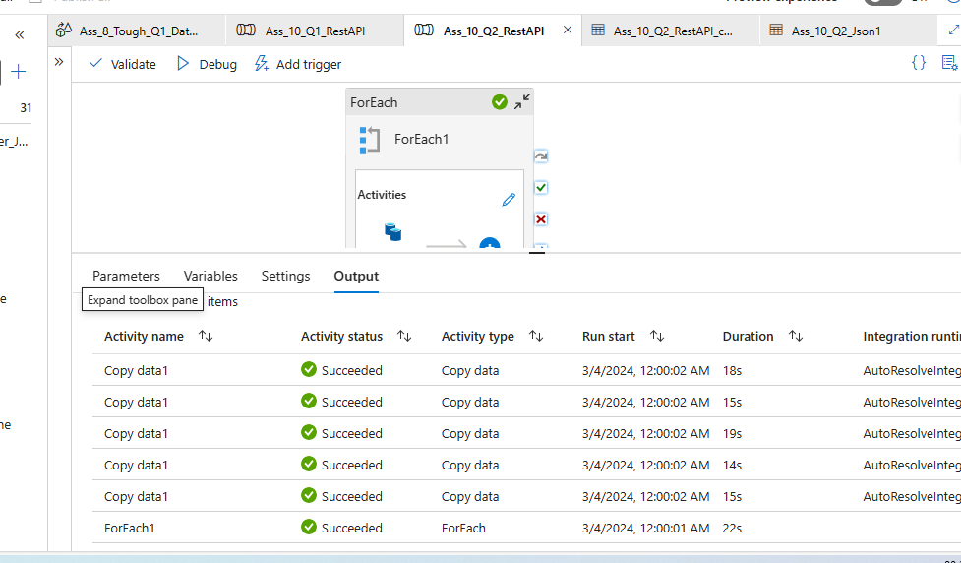

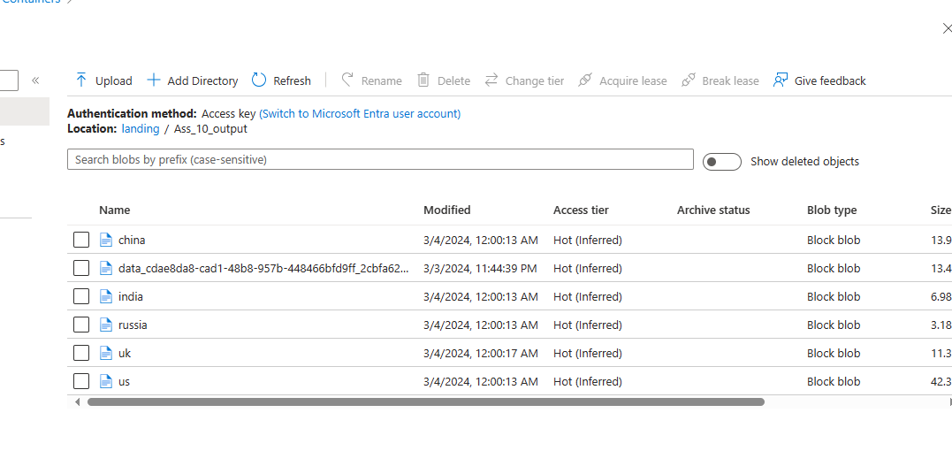

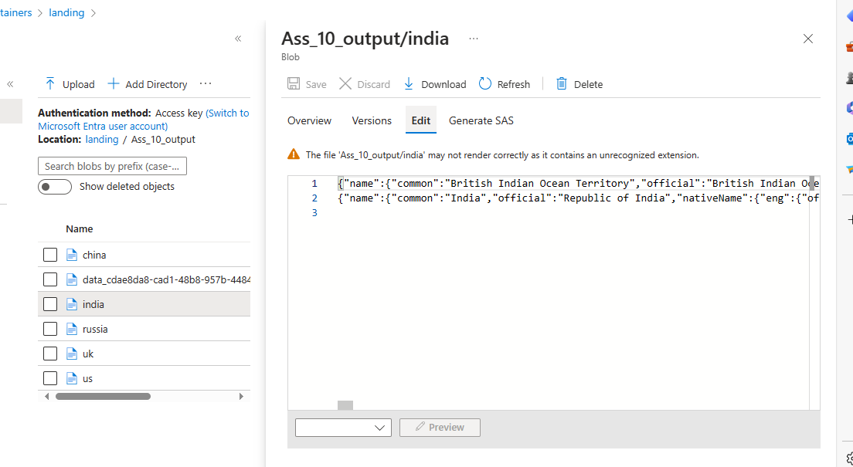

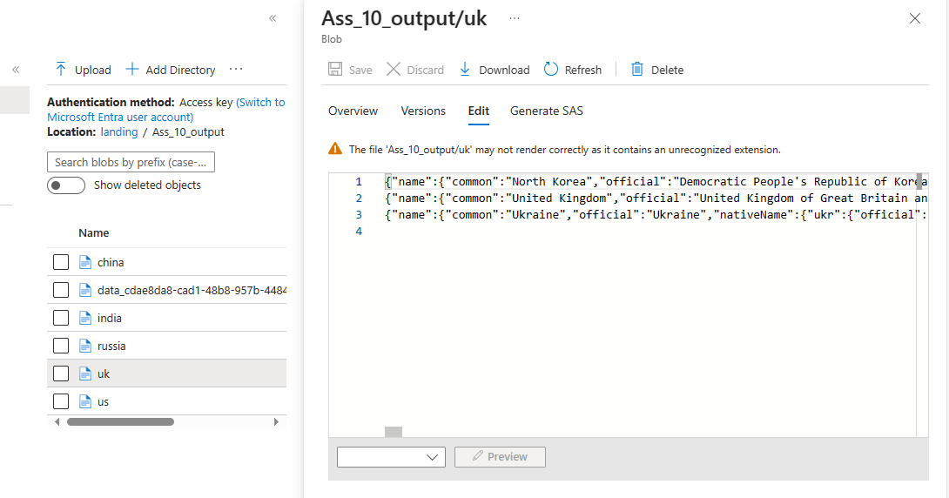

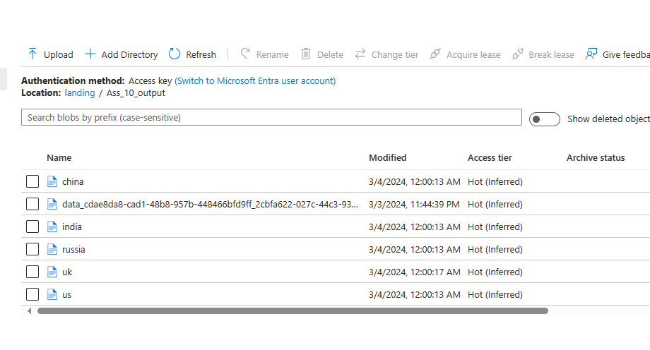

Question 3:

3. Add the trigger to above pipeline in such a way that it will automatically run two times in a day ( 12:00 AM and 12:00 PM IST)
Tip: Incase you can't able to do Q2, do this on Q1

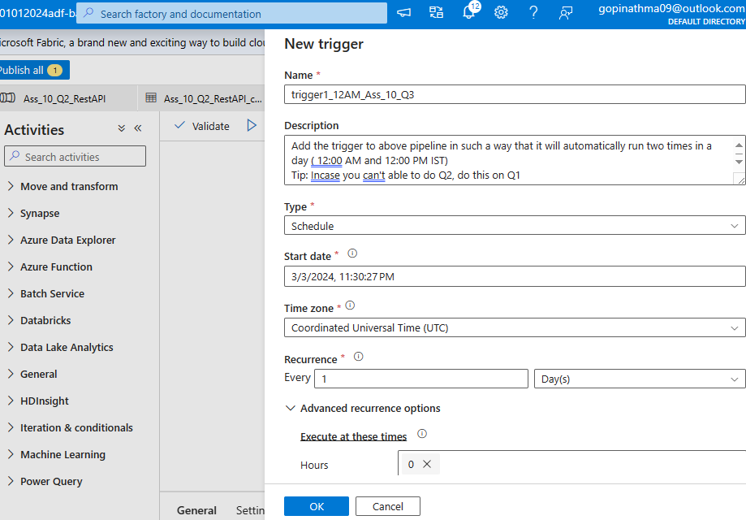

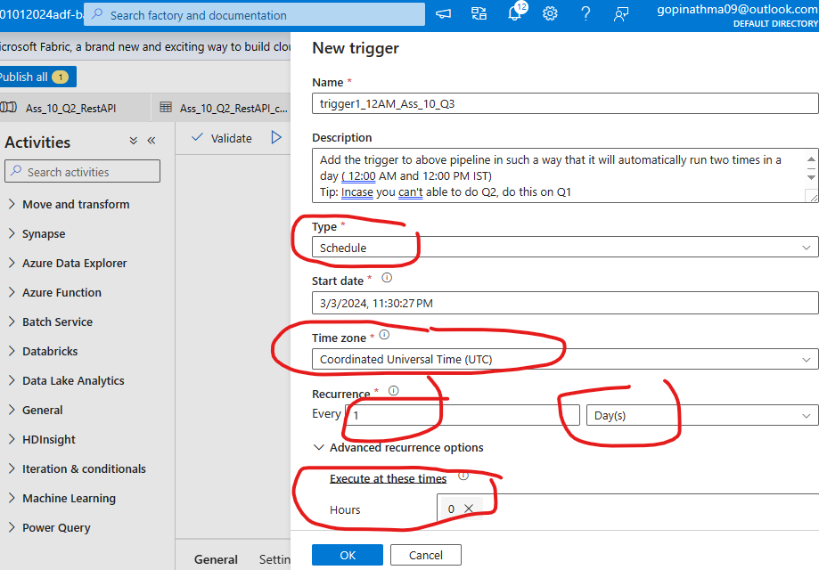
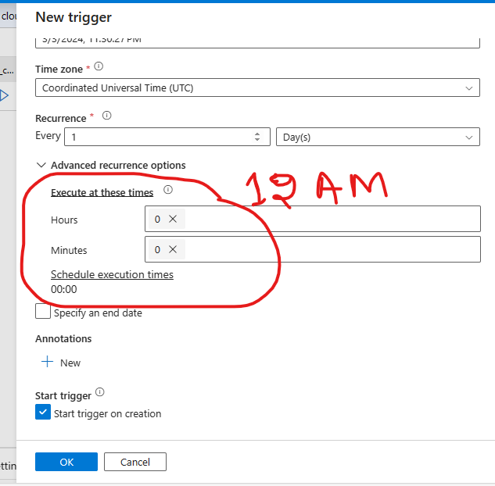
Press OK above

And
Now create Trigger for 12PM

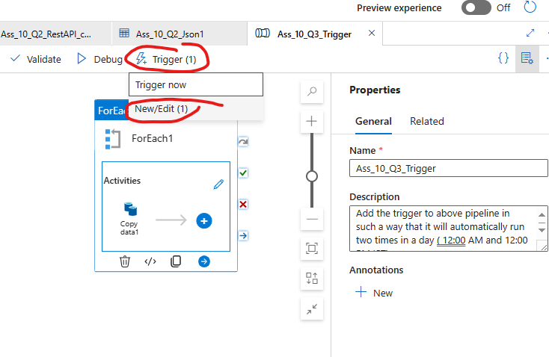

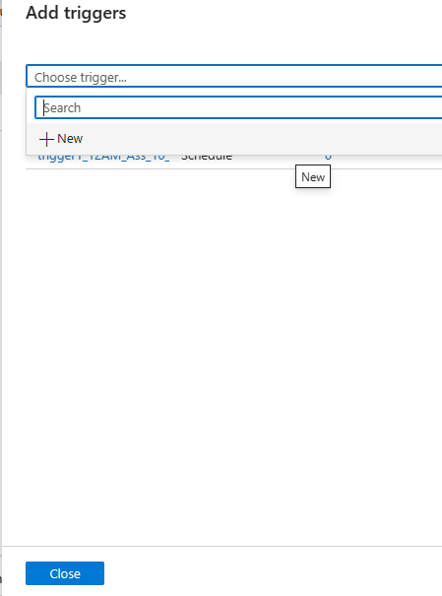

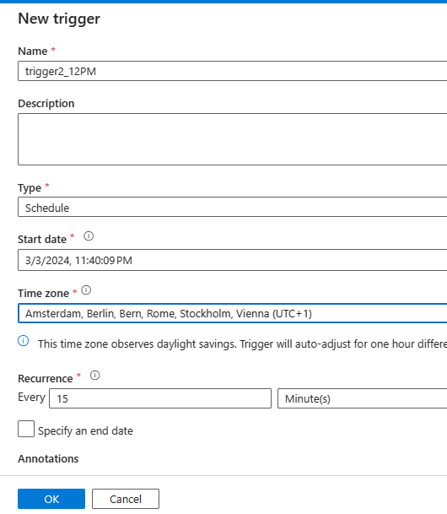

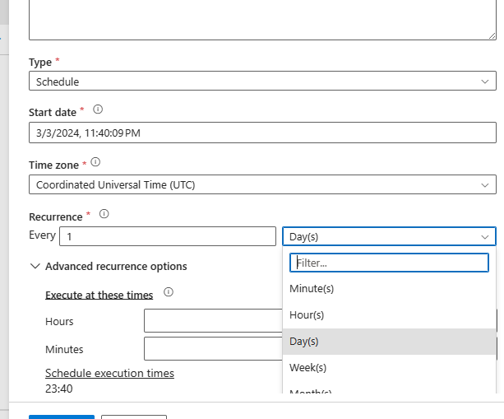

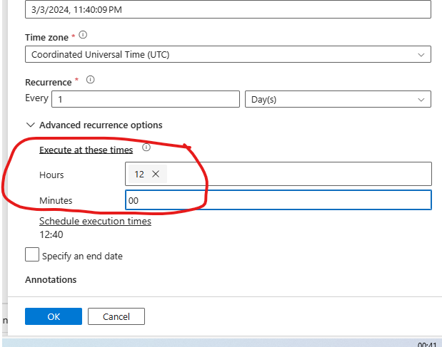

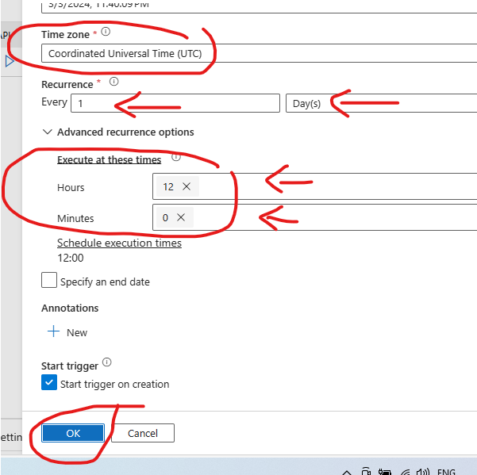

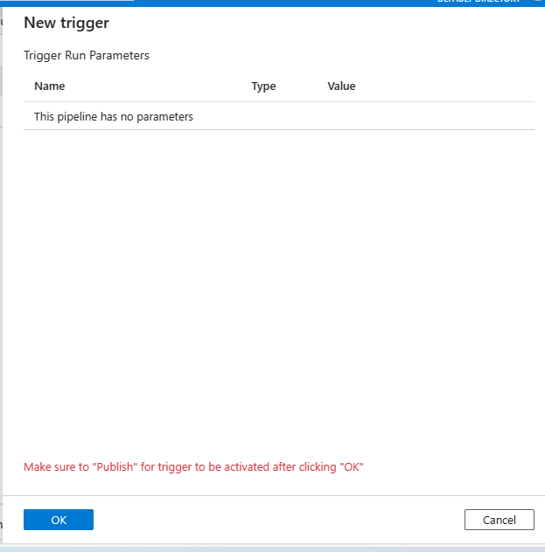

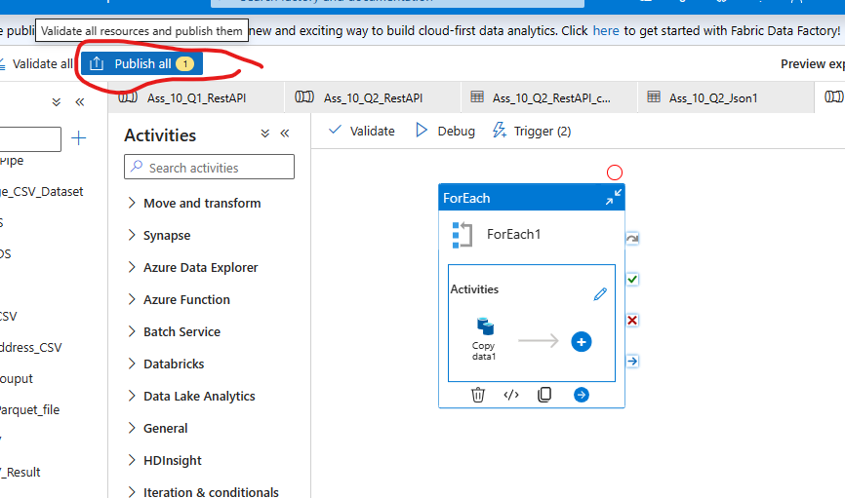

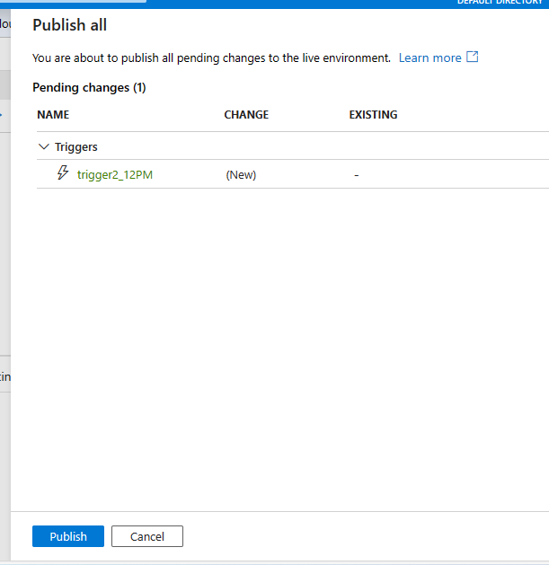

Question 4:

4. Now to make it more realistic, as soon as any copy activity fails in the above pipeline send an automated email to notify user.

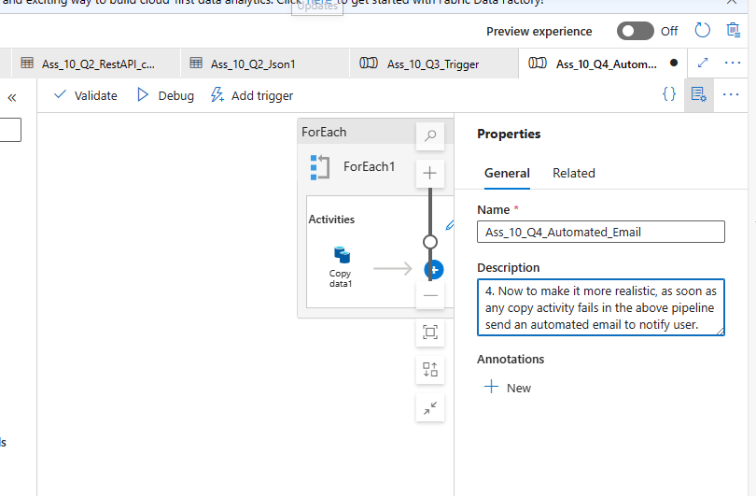

Same pipleine cloned form previous quesitons “For Each Activity” from Question 1 of Assignment:

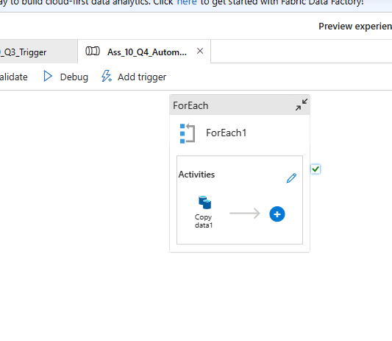
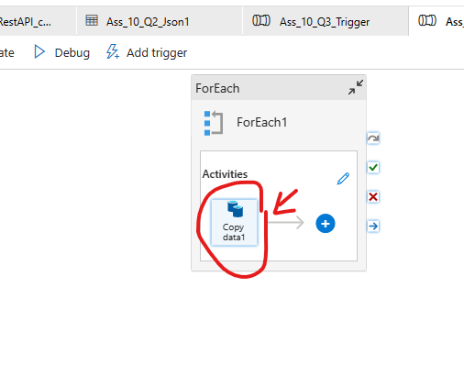

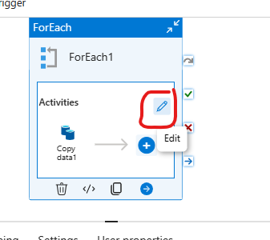

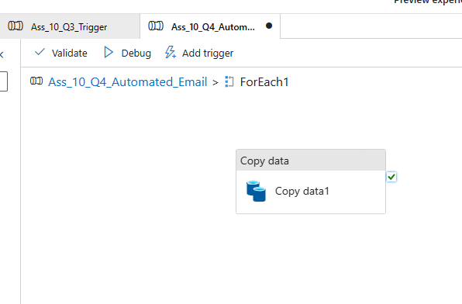

Use WebActivity (After Copy gets success)

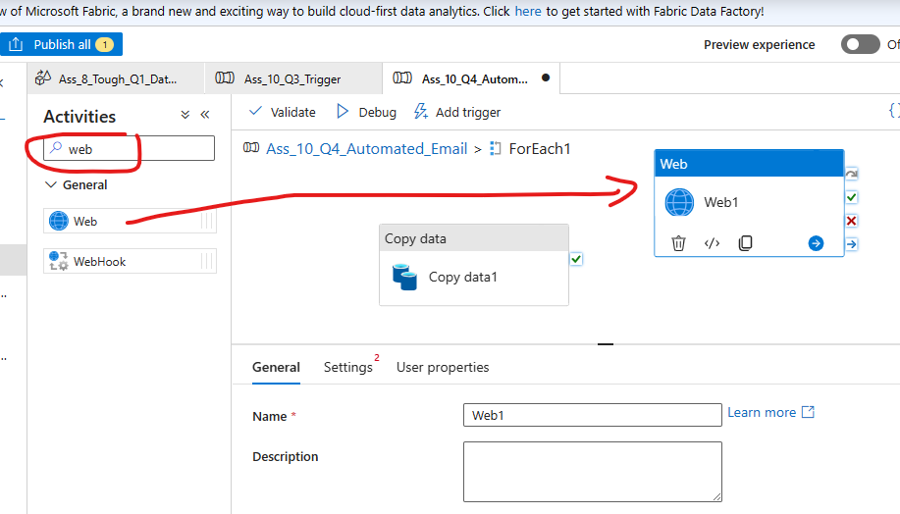

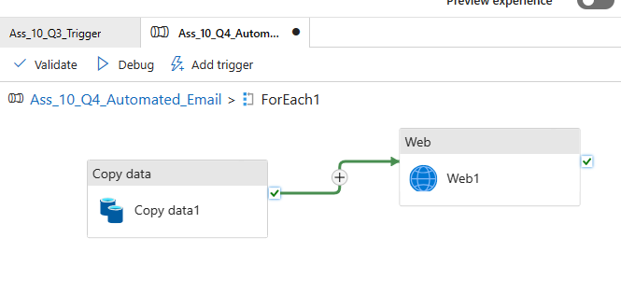

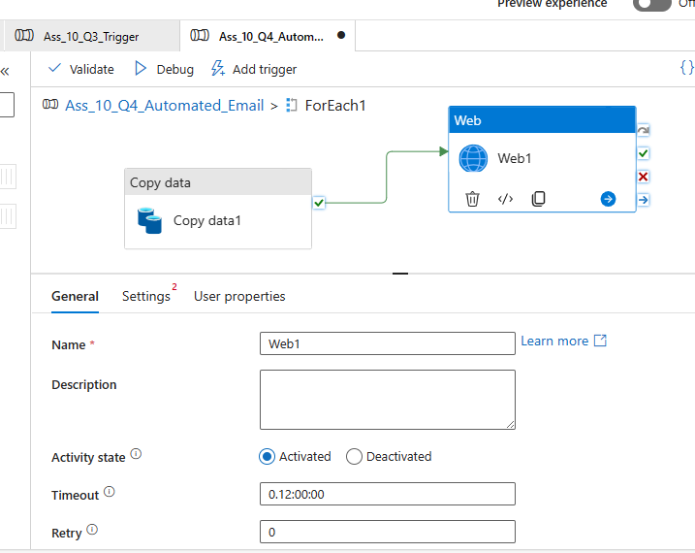

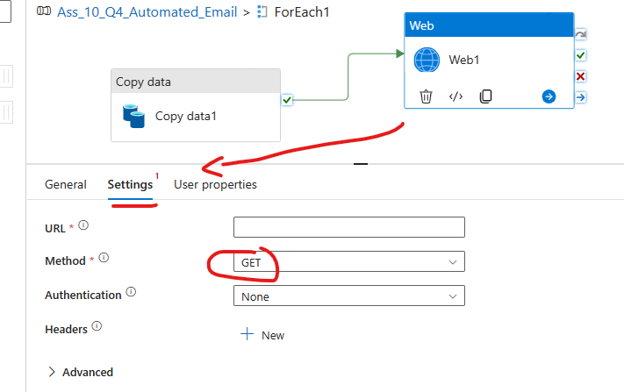

For Email creation – u need to create logic app (Search for “Logic App” in search box)
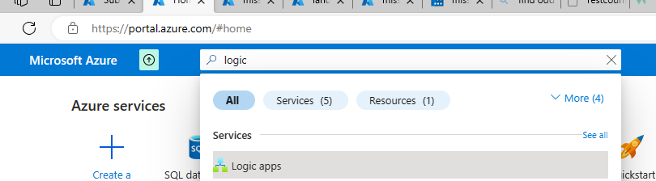

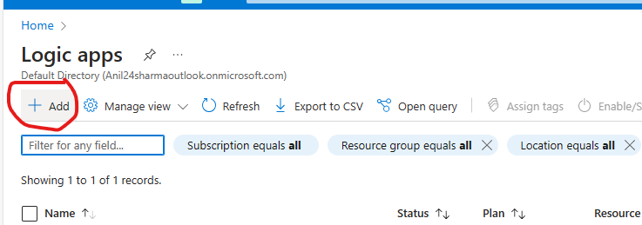
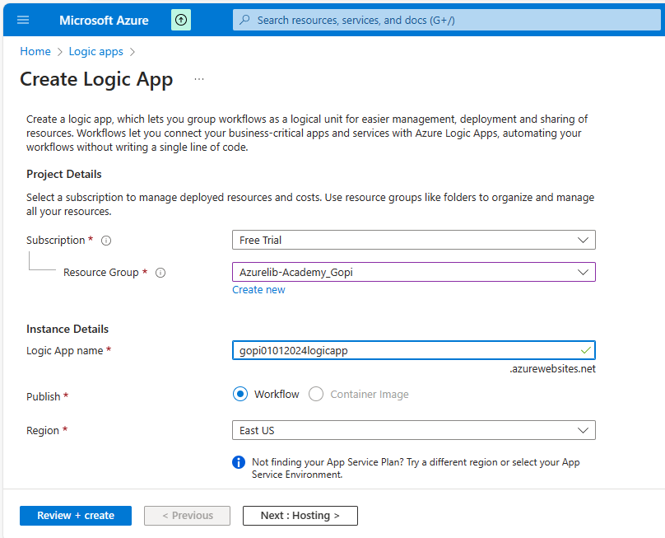

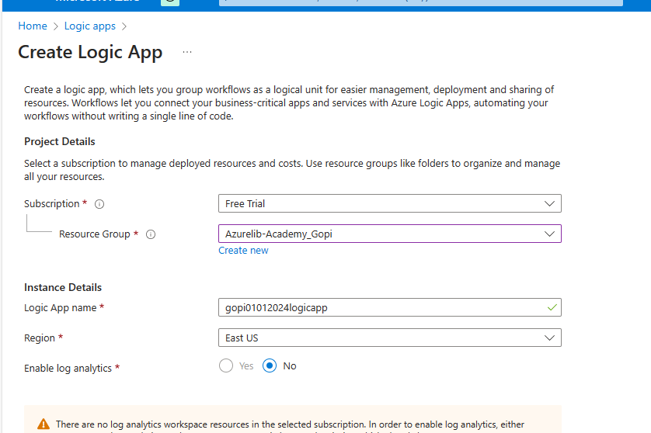

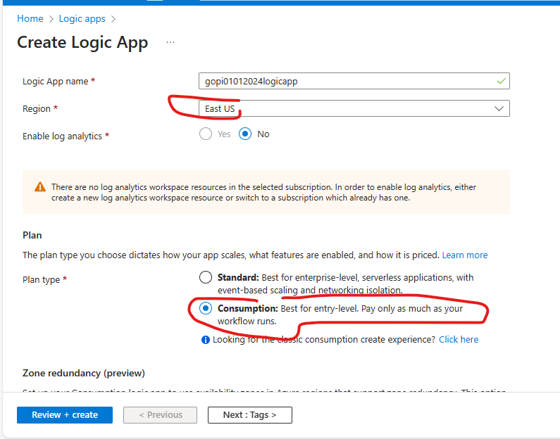

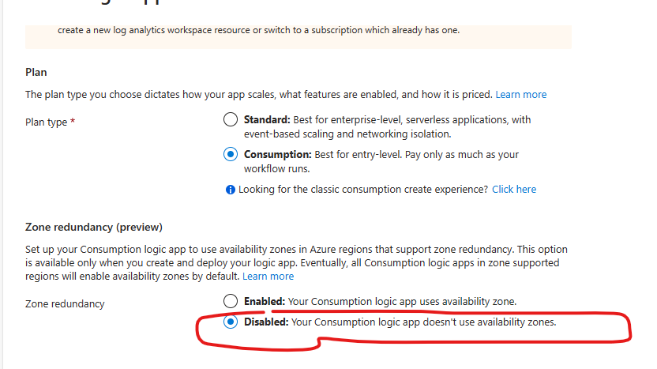

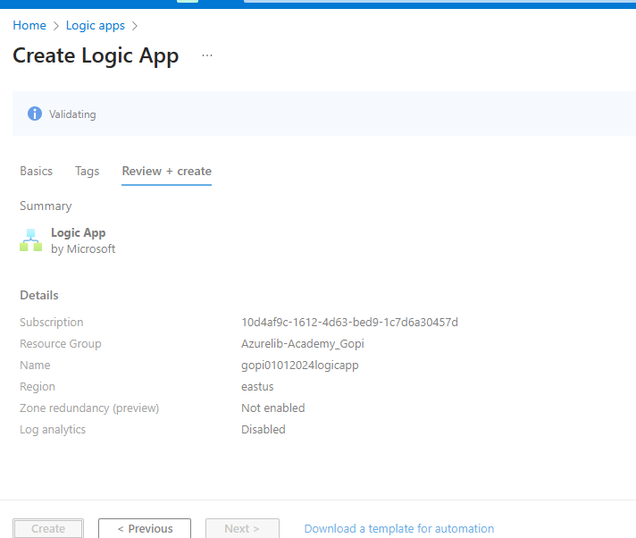

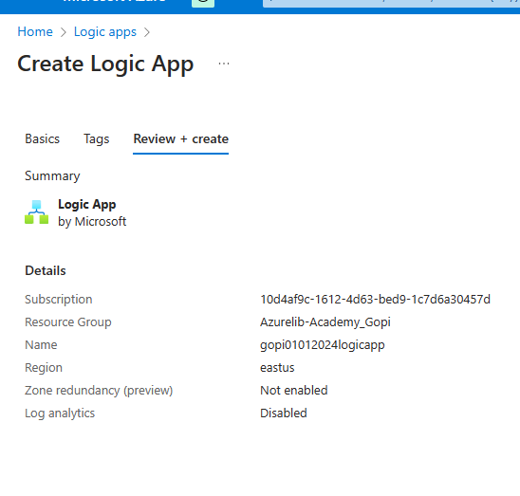

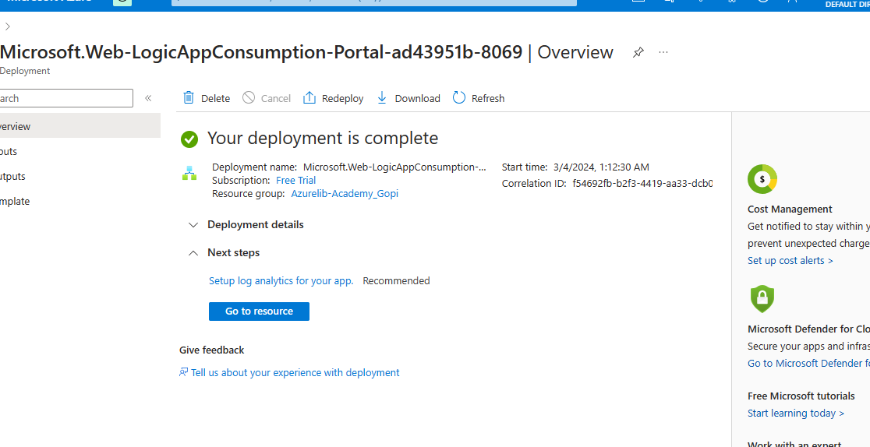

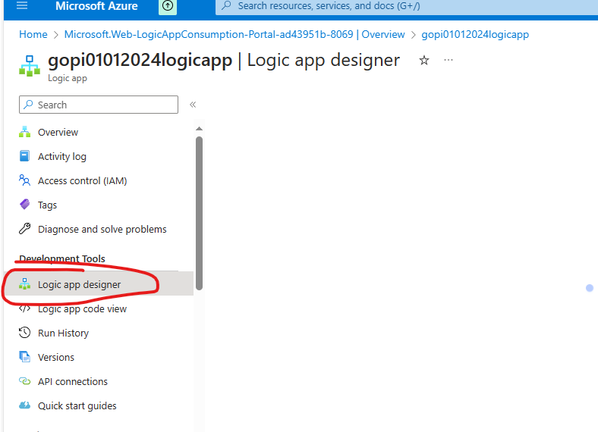

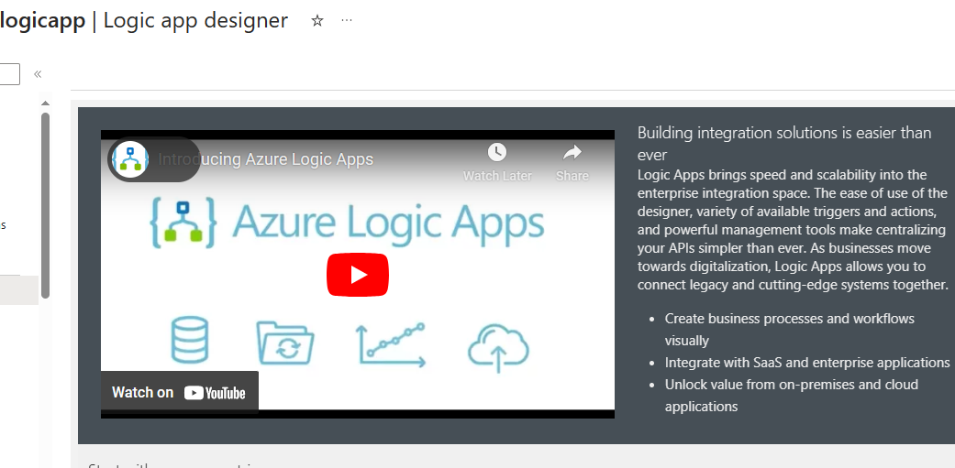

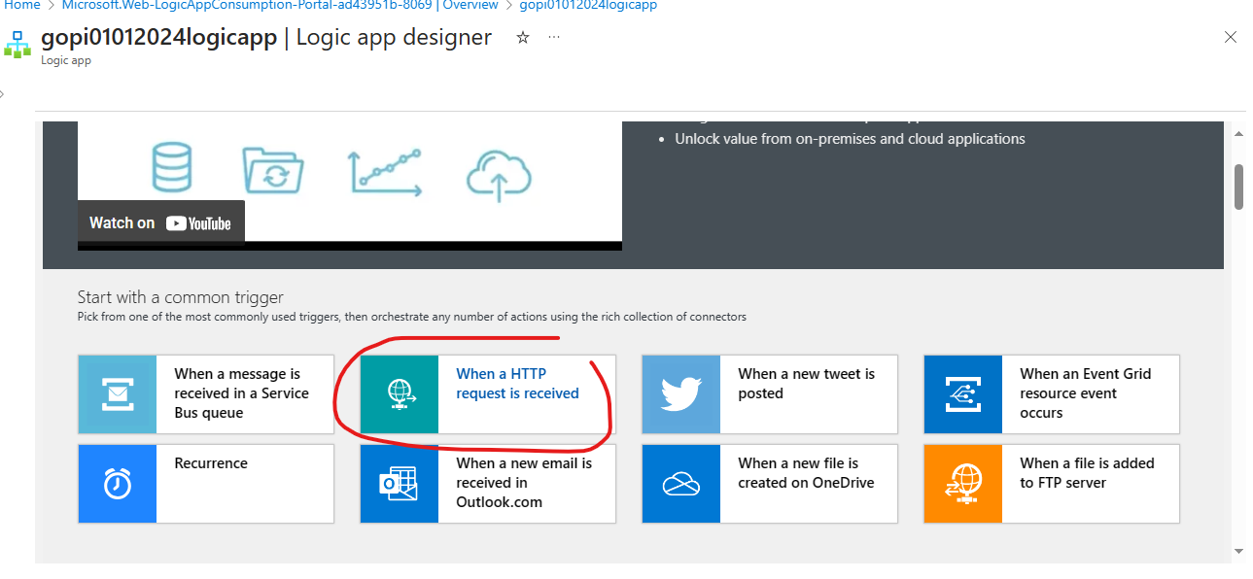

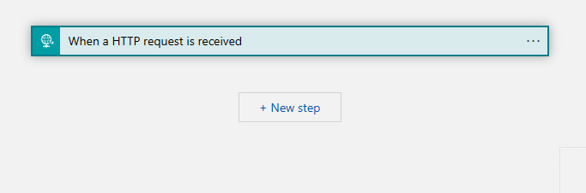

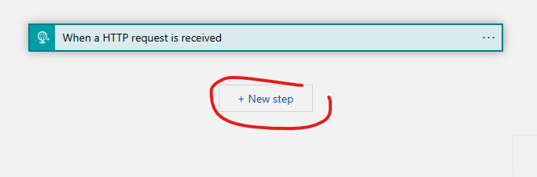

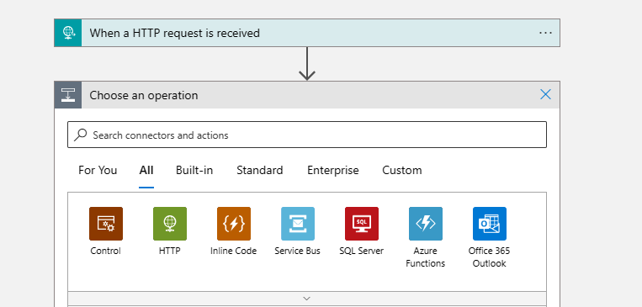

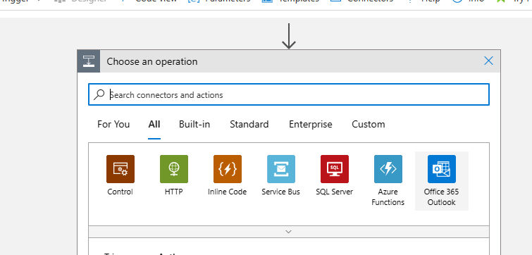

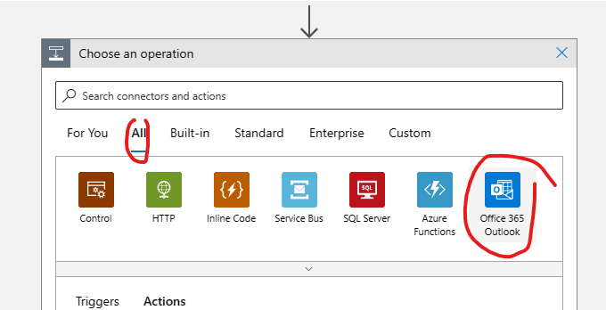

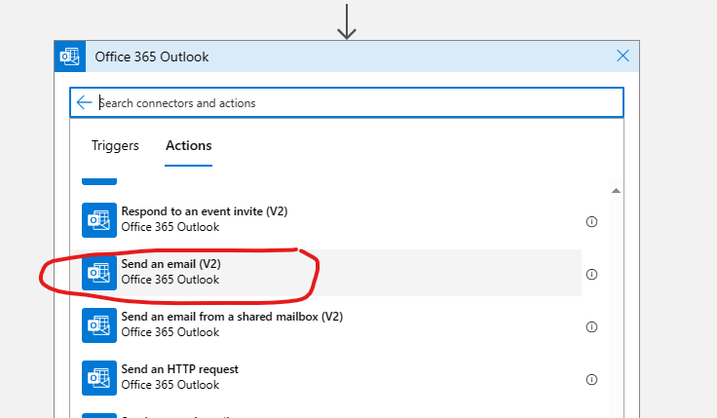

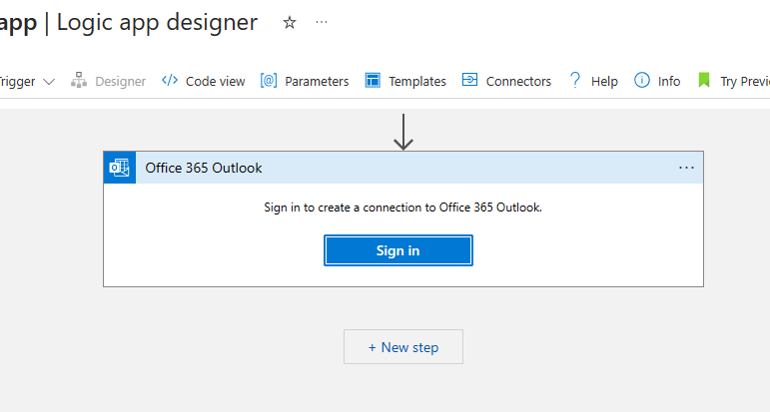

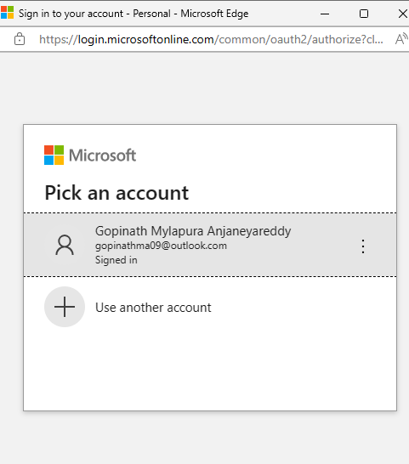

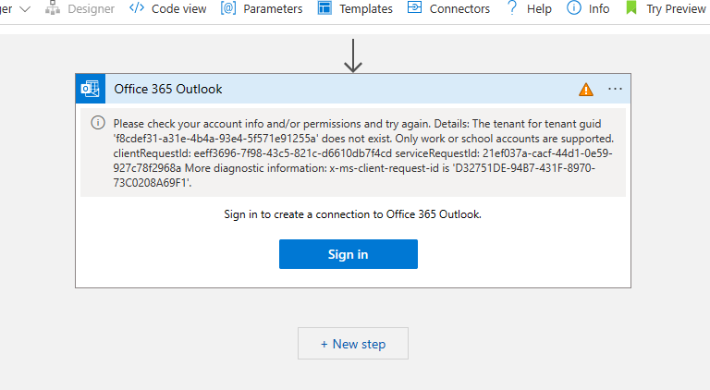

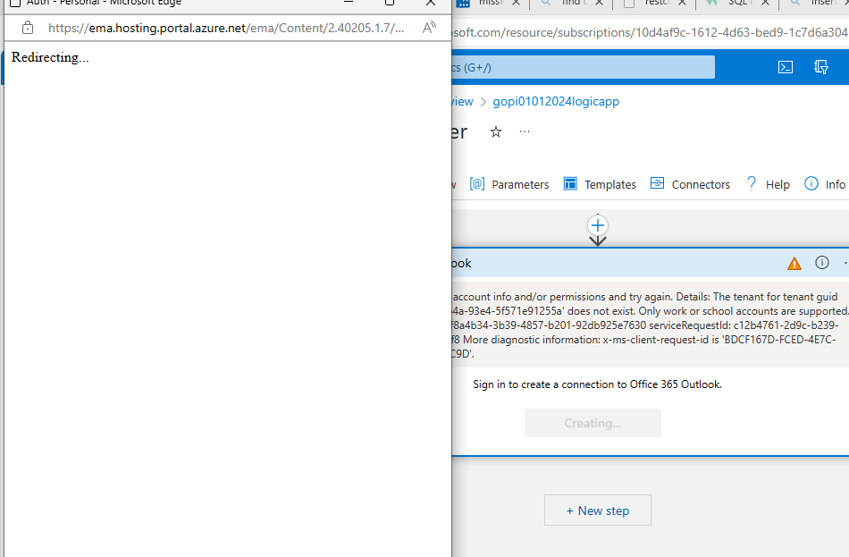

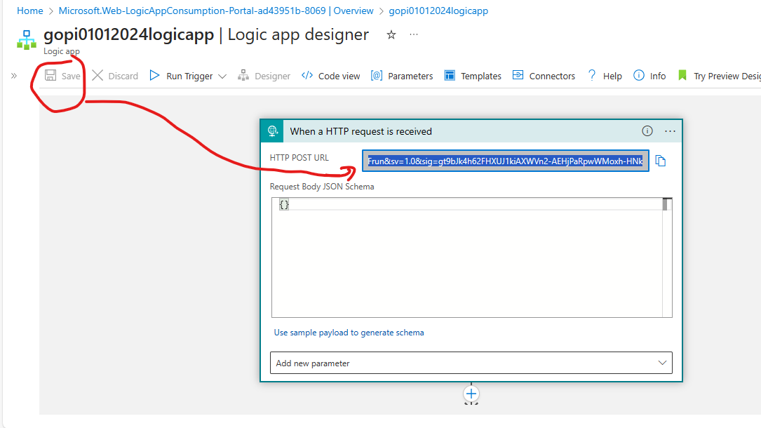

Copy HTTP POST URL:

https://prod-36.eastus.logic.azure.com:443/workflows/1ac08d815250464a9265aabb325174e2/triggers/manual/paths/invoke?api-version=2016-10-01&sp=%2Ftriggers%2Fmanual%2Frun&sv=1.0&sig=gt9bJk4h62FHXUJ1kiAXWVn2-AEHjPaRpwWMoxh-HNk

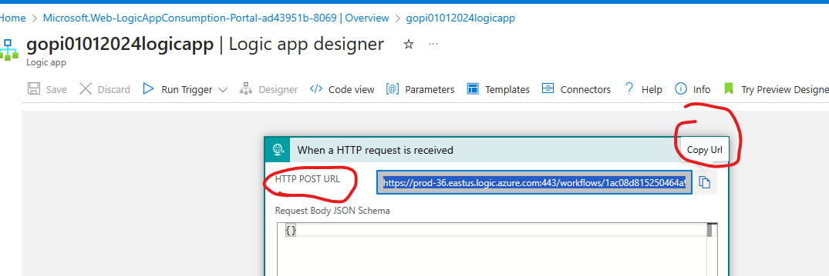

For me above did not work so trying GMAIL

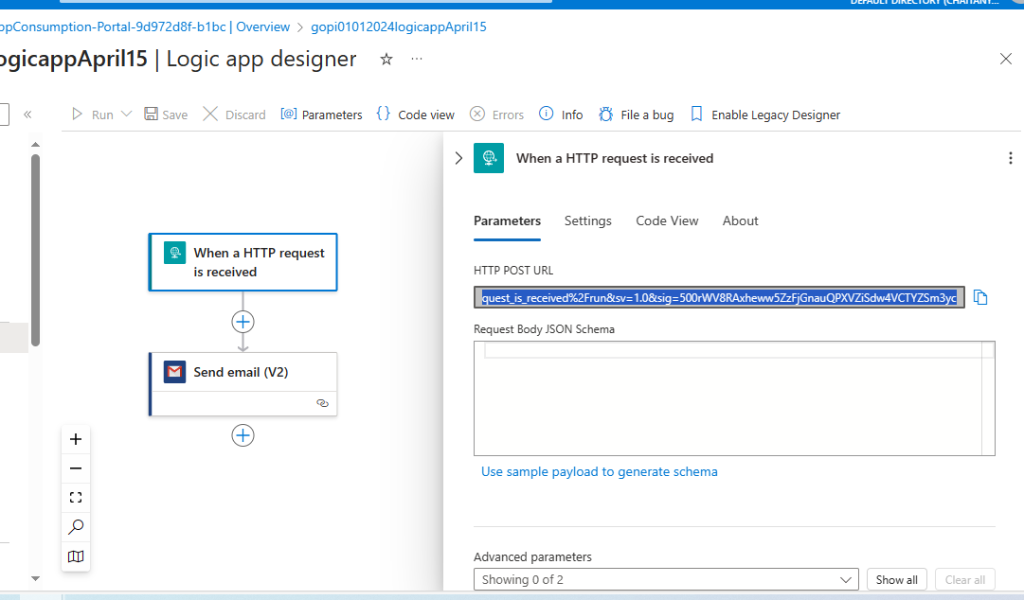

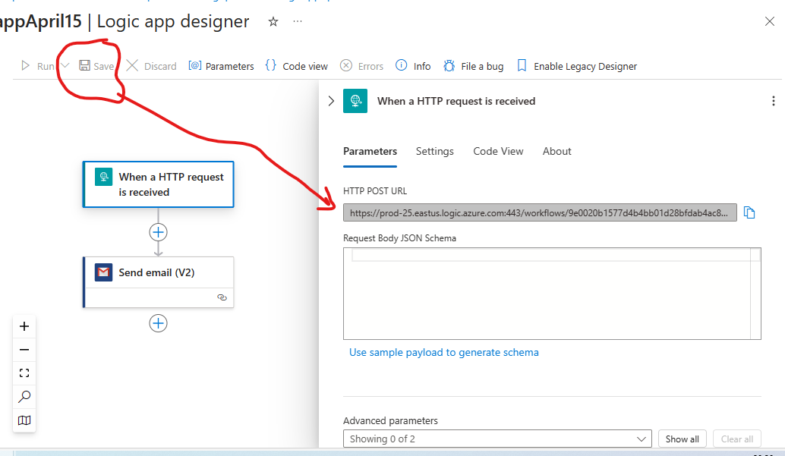

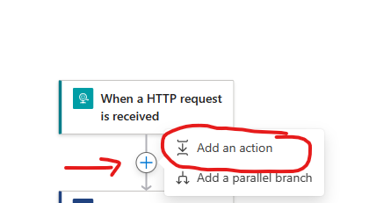

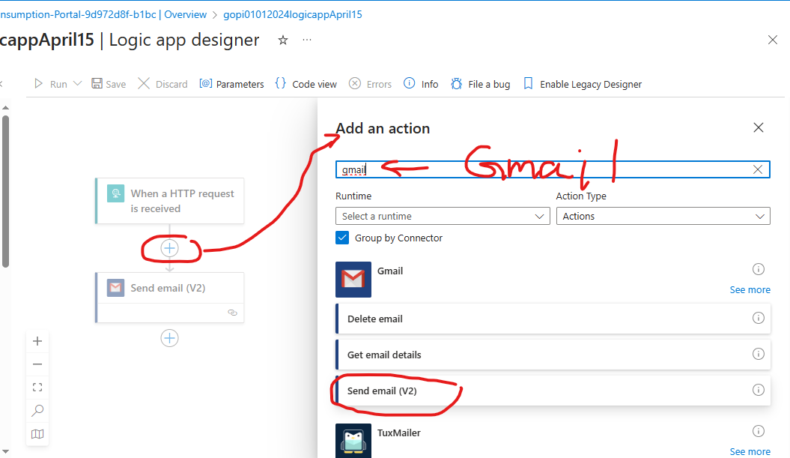
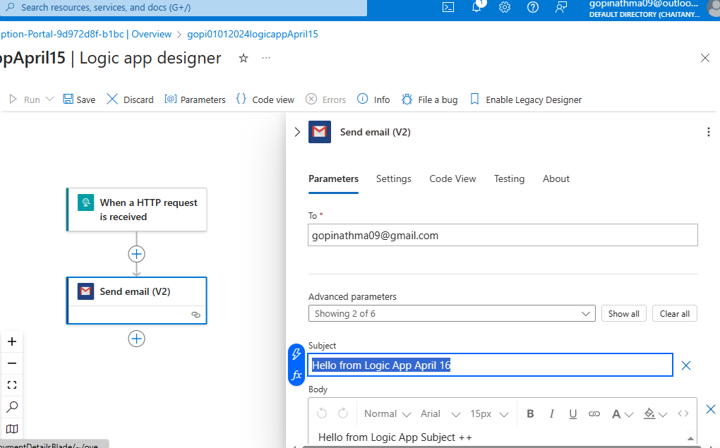

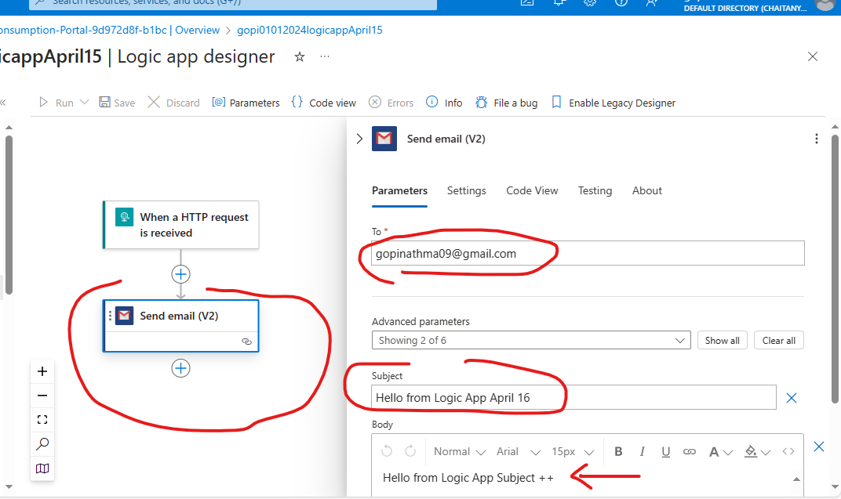
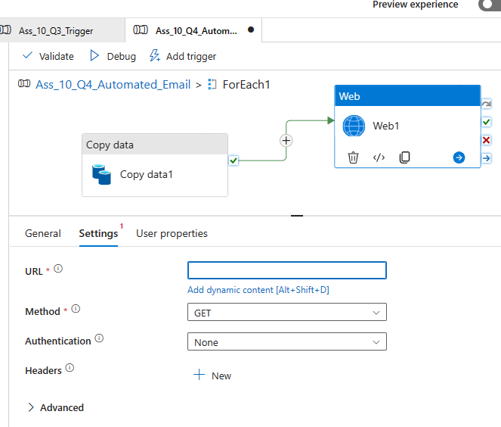

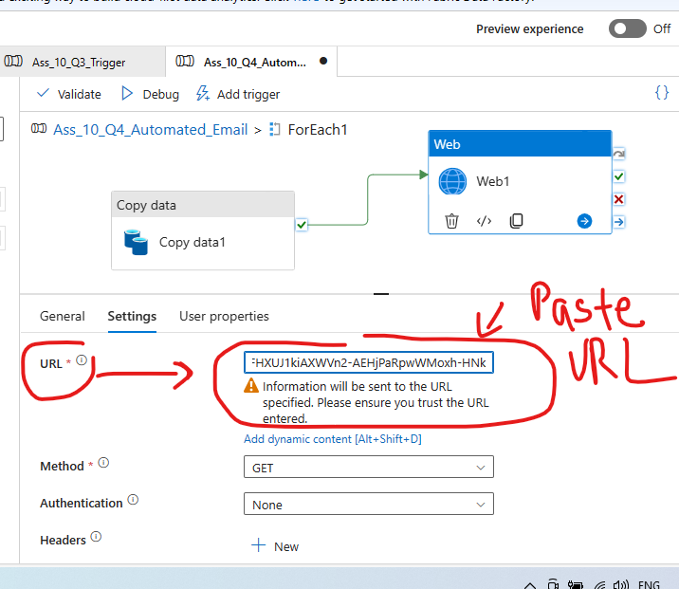

- Check Request Content: Review the content of the request you are sending to ensure that it is formatted correctly and does not contain any unexpected characters.
- Validate JSON Format: Ensure that the request content is valid JSON format. JSON should start with a { character and end with a } character, with key-value pairs separated by commas. Also, make sure that all strings are enclosed in double quotation marks (").
- Check for Special Characters: Look for any special characters or symbols in the request content that might be causing parsing errors. These characters should be properly escaped according to JSON syntax rules.

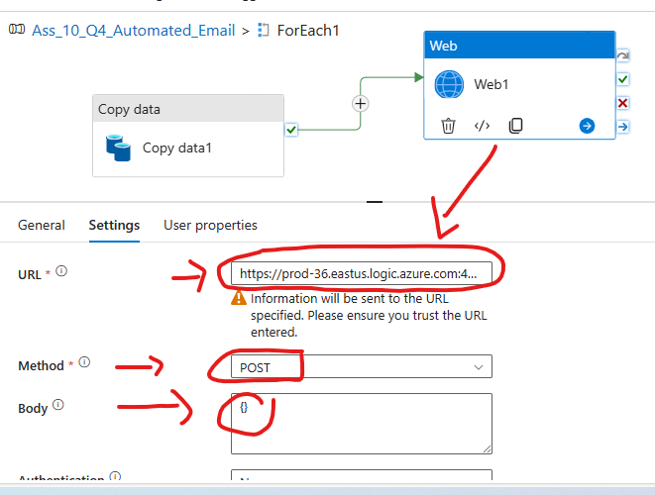
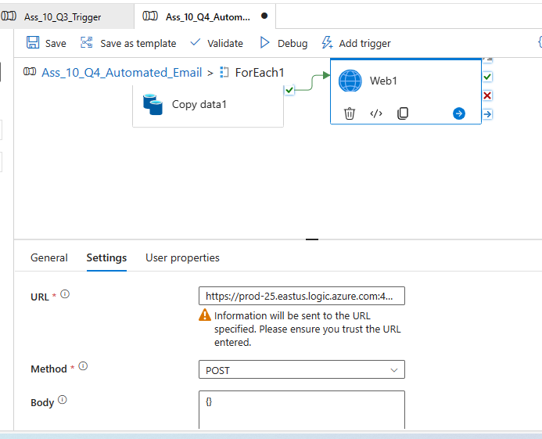
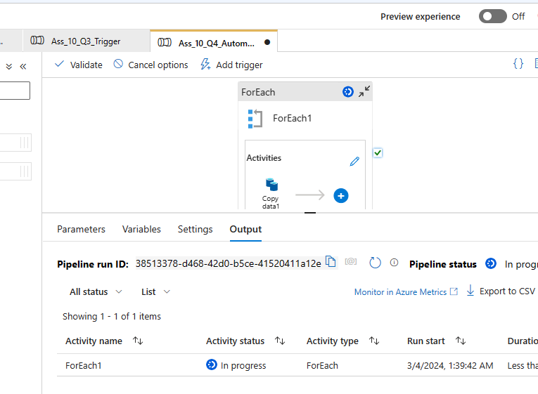

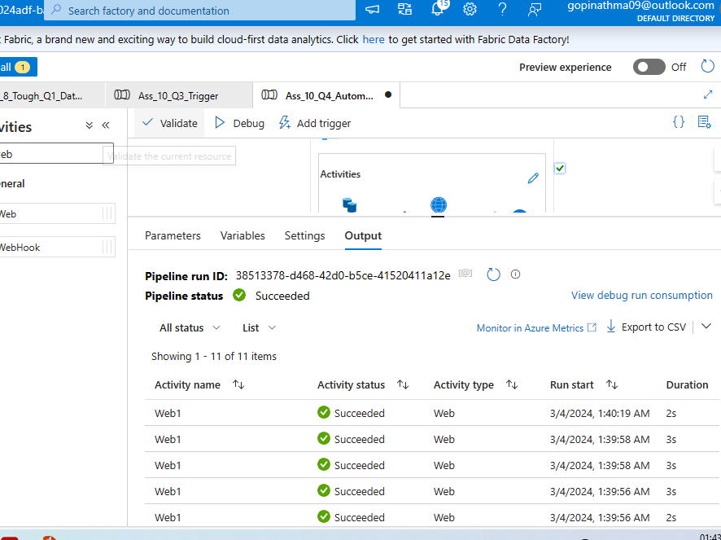

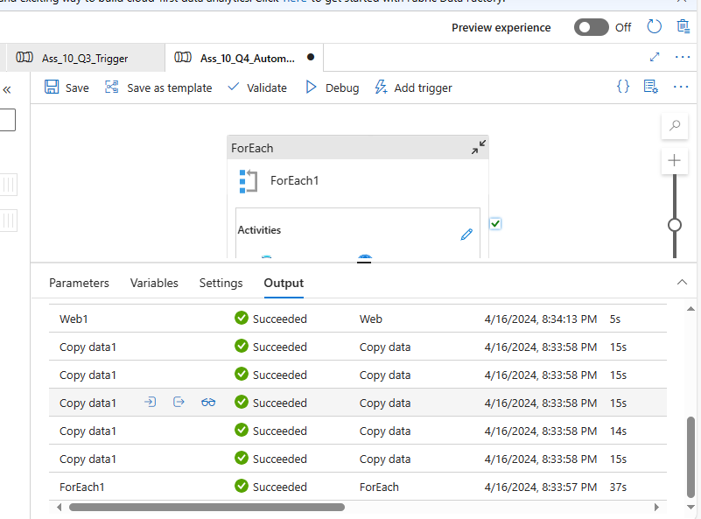

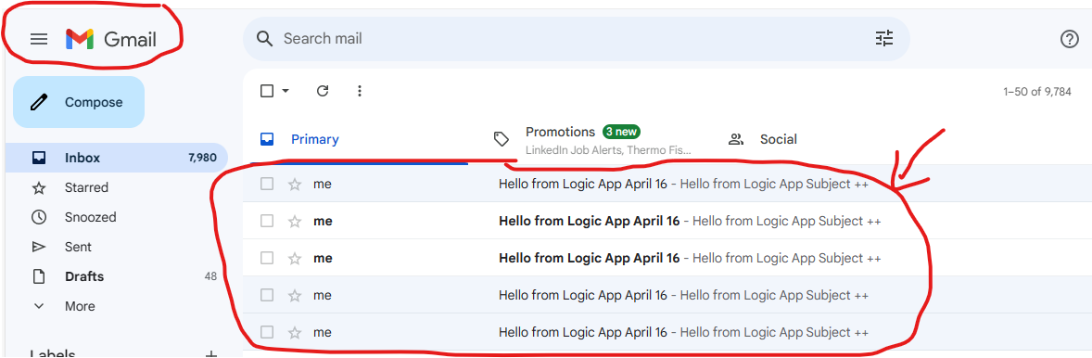

5 Emails Received : Because For 5 countries of RestAPI -->For Each copy Activity happened 5 times,
so 5 GMAILS Emails Triggered
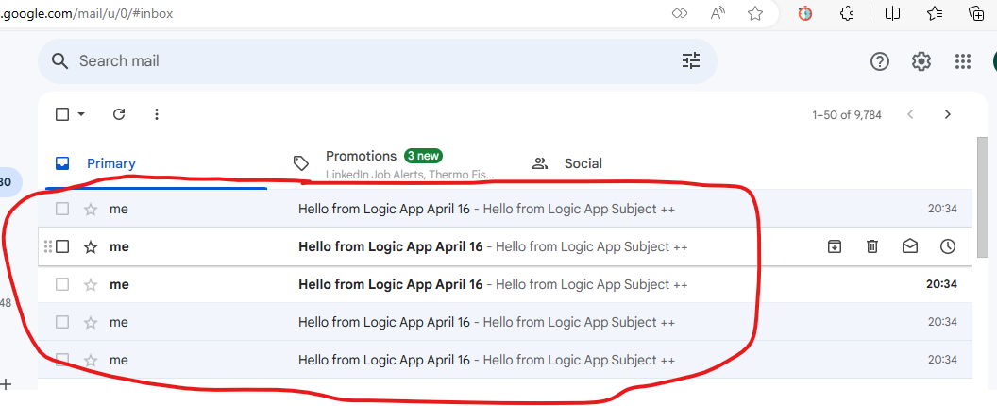

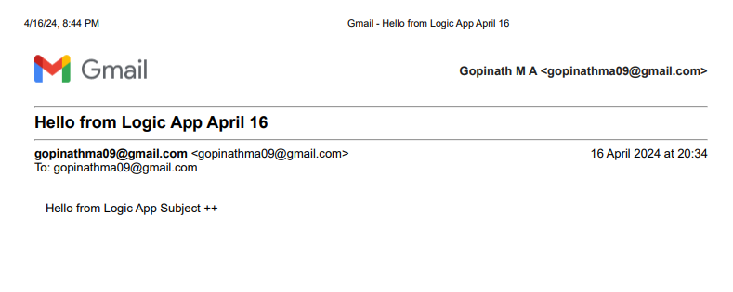

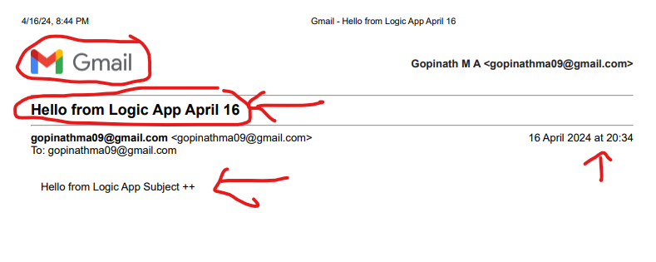

Question 5:

5. Make the mail more generic by sending the Pipeline name, Status, SenderMailiD, and Name within the mail. Ensure mail will come in case of both success and Fail

Make mail generic

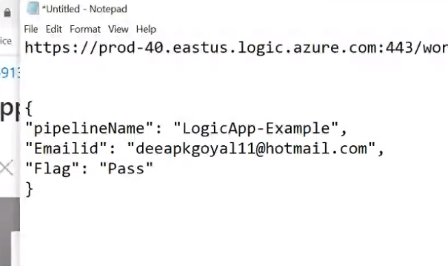

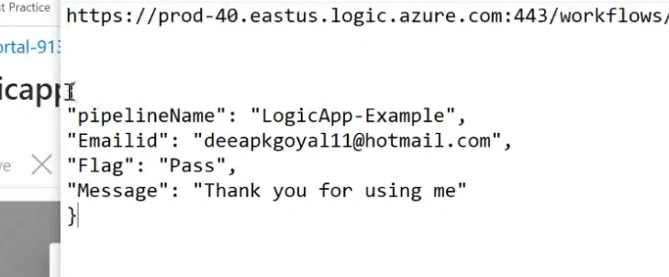

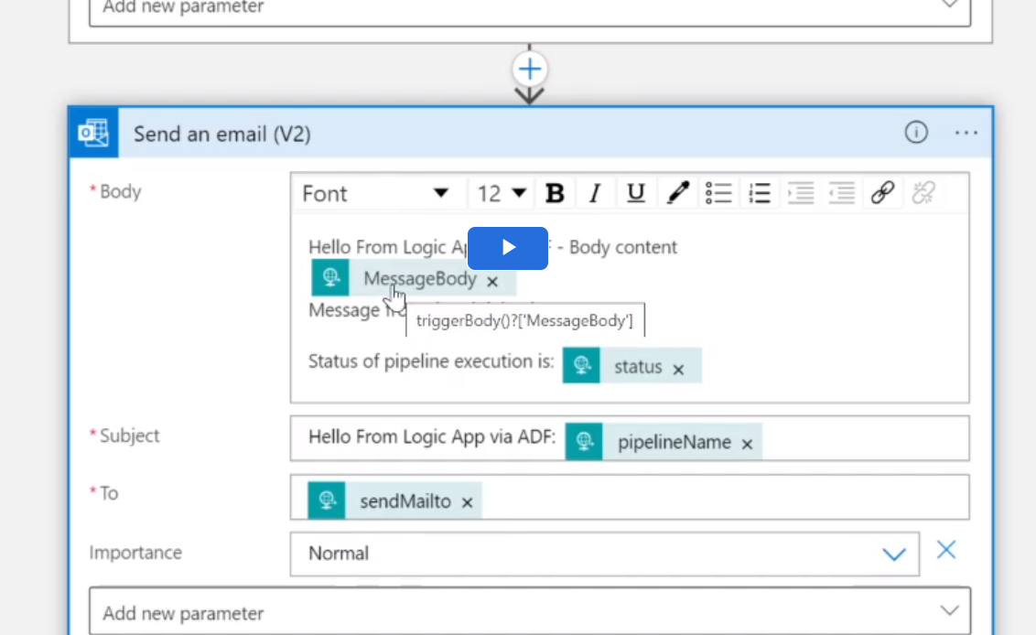

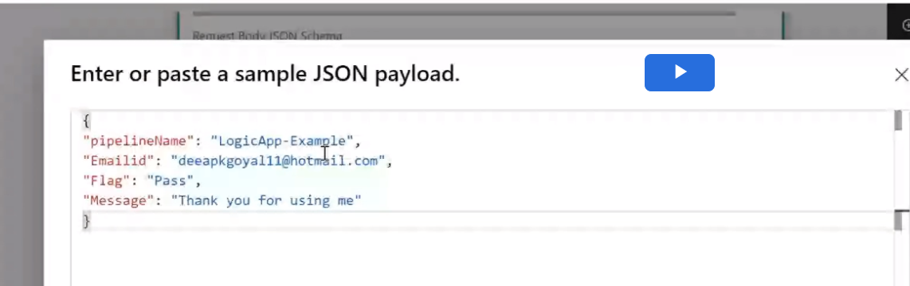

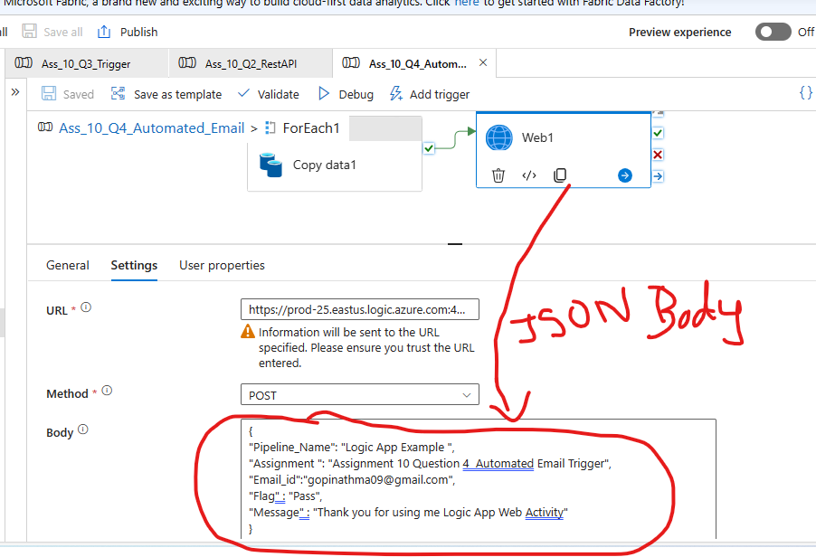

Go to Logic App:
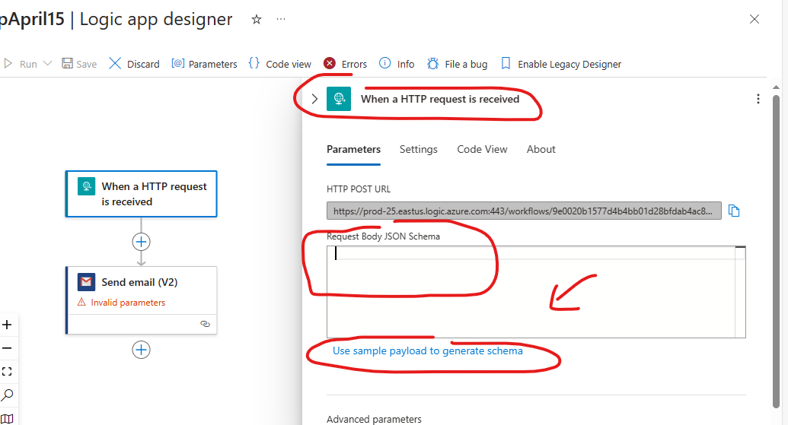

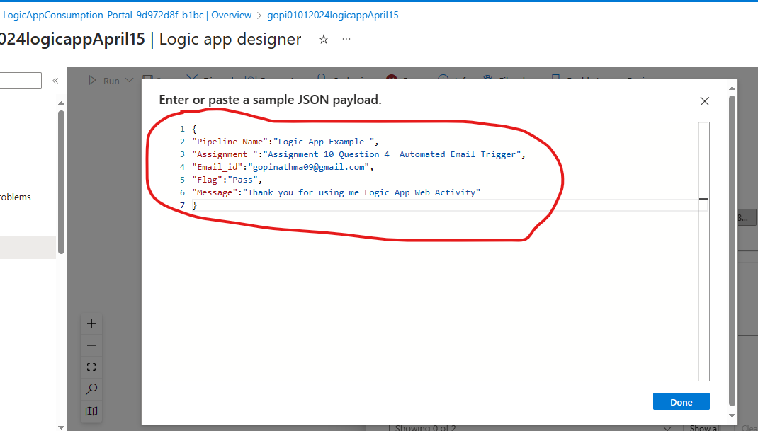

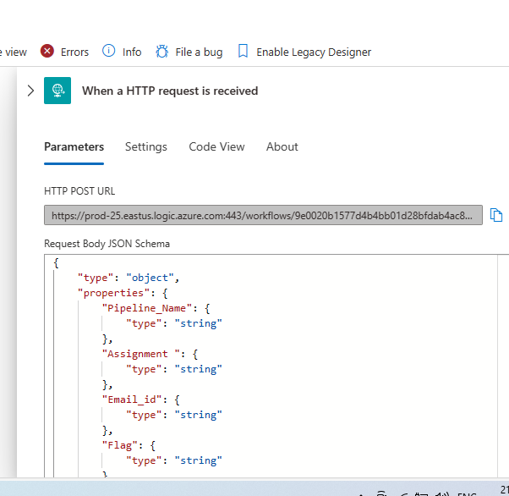

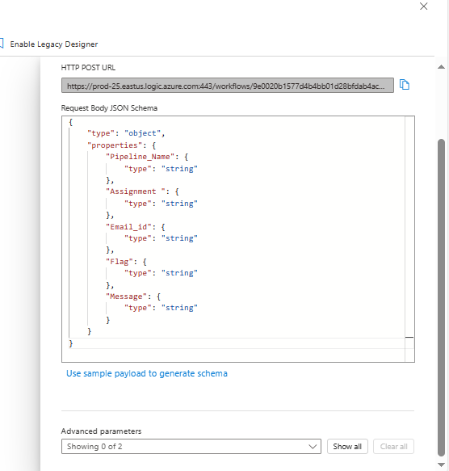

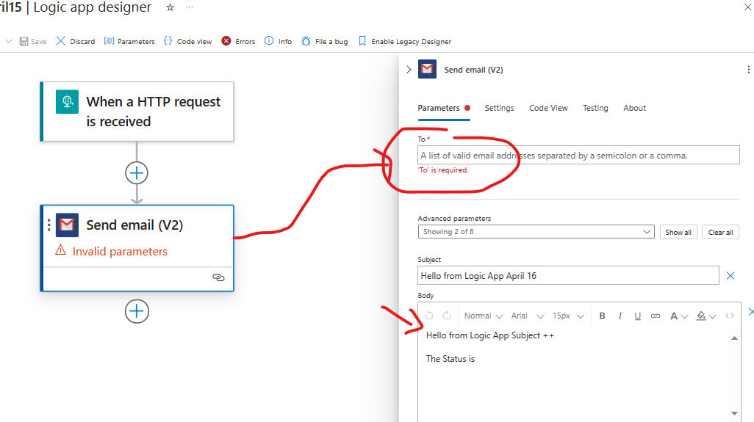

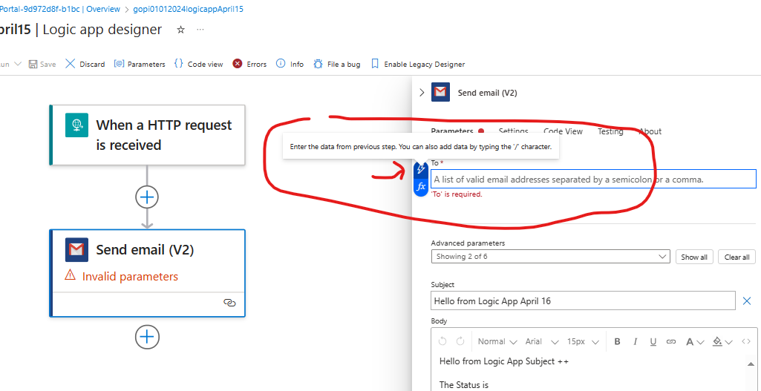

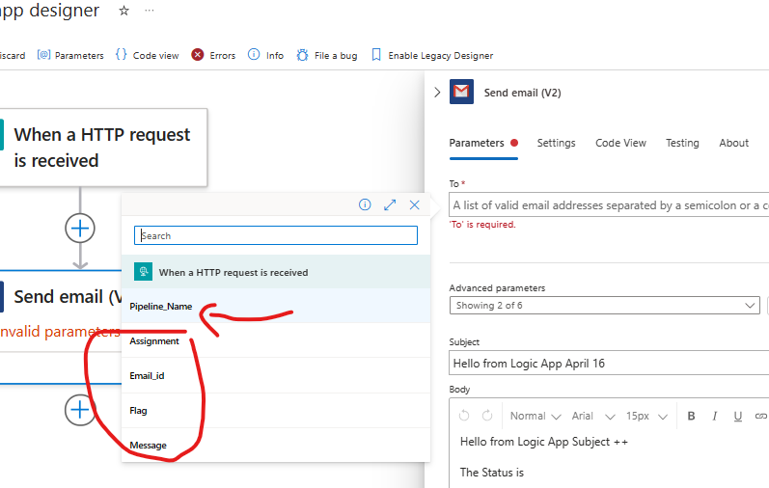

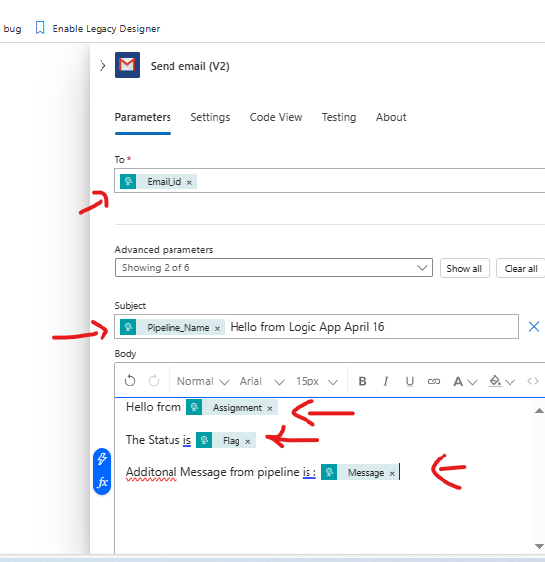

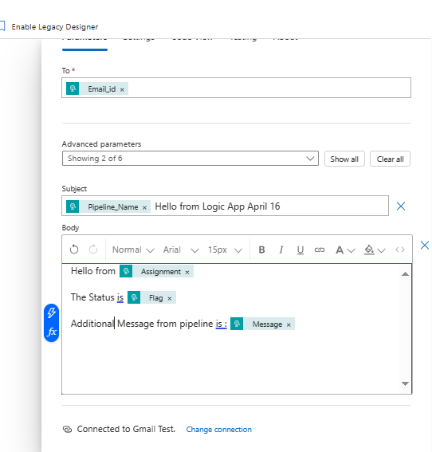

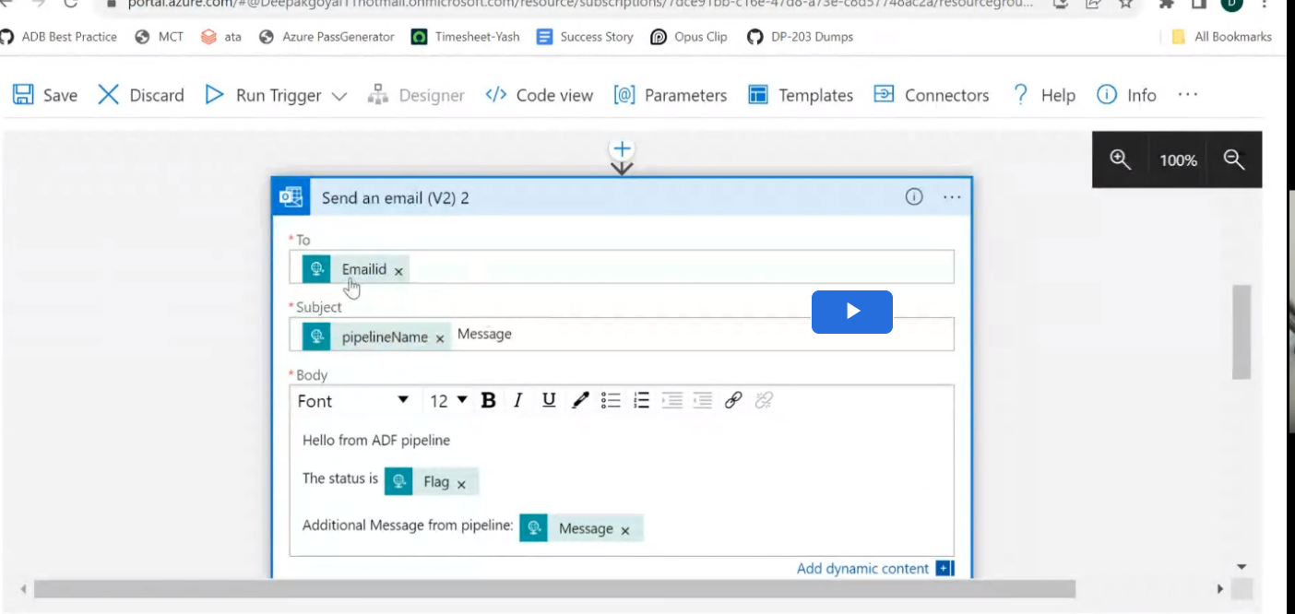

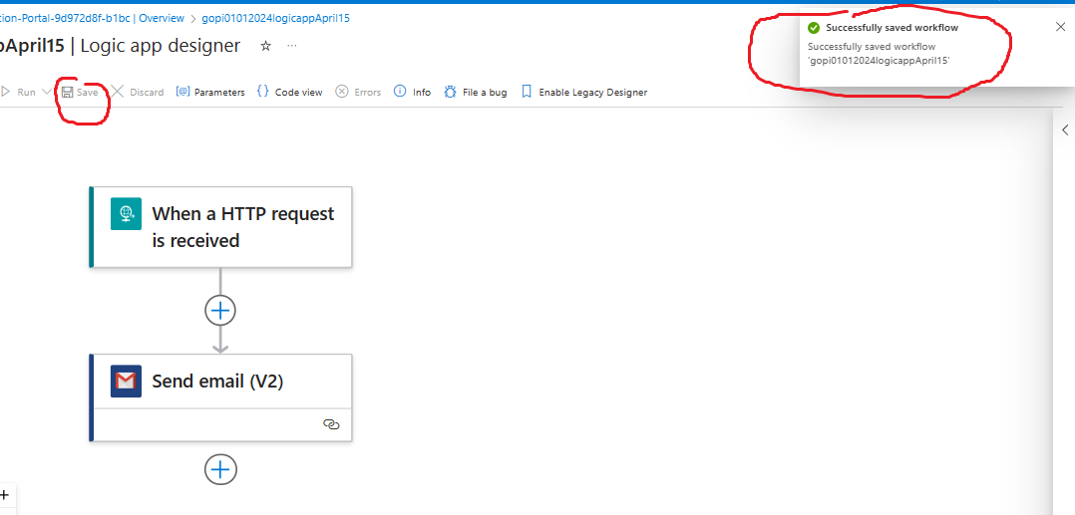

Make the mail more generic by sending the Pipeline name, Stauts, SenderMailiD, and Name within the mail. Ensure mail will come in case of both success and Fail.

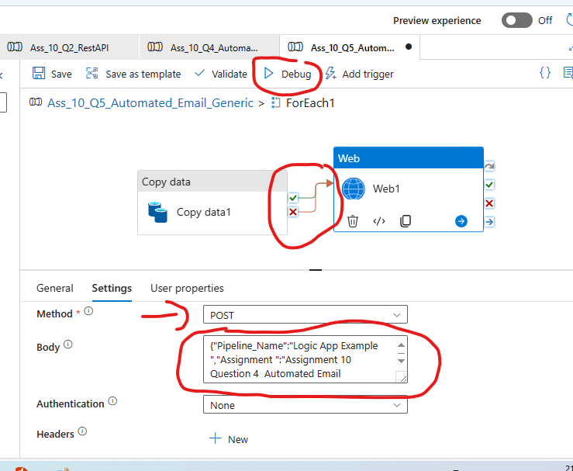

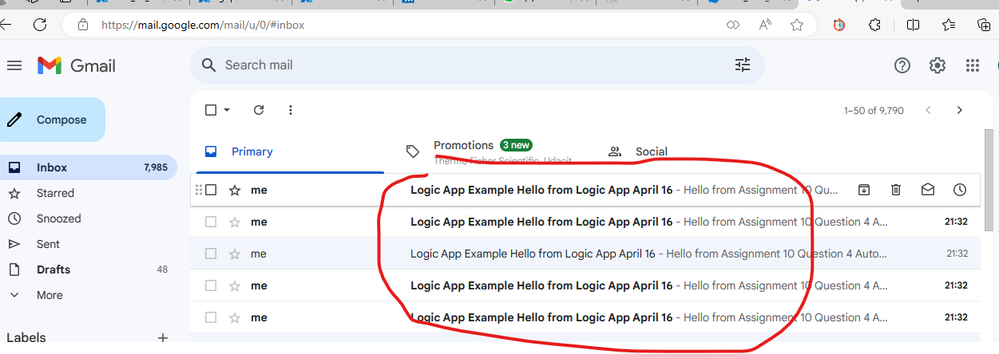

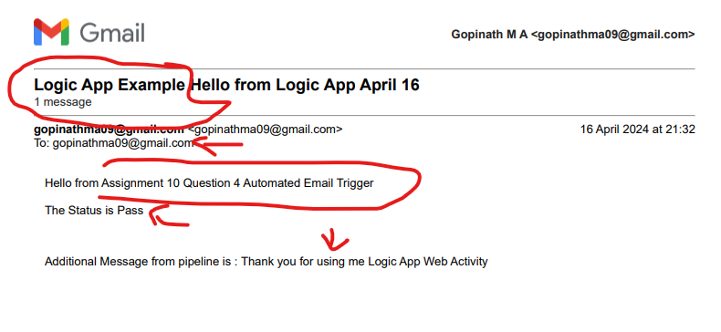

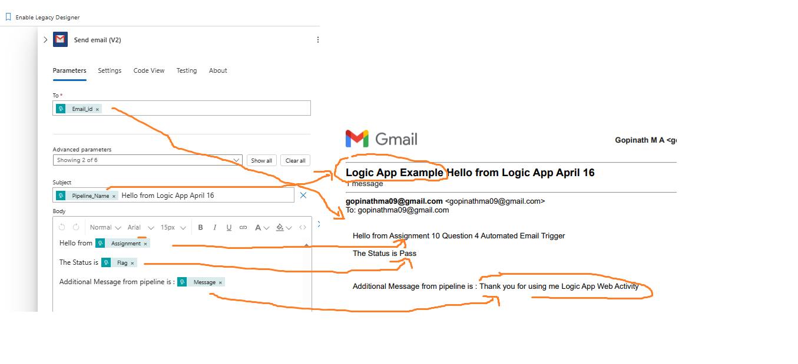

Just of Expereimenting:
Failed Sceneario by giving “indai1” in place of “india” in foreach activity
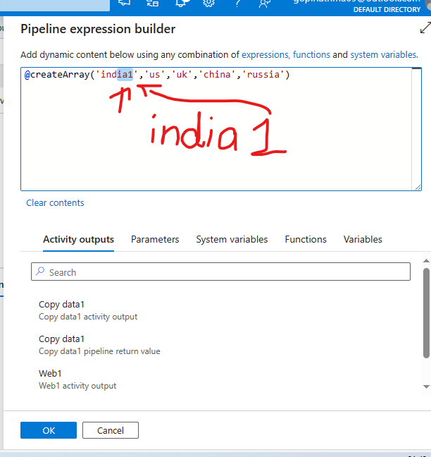
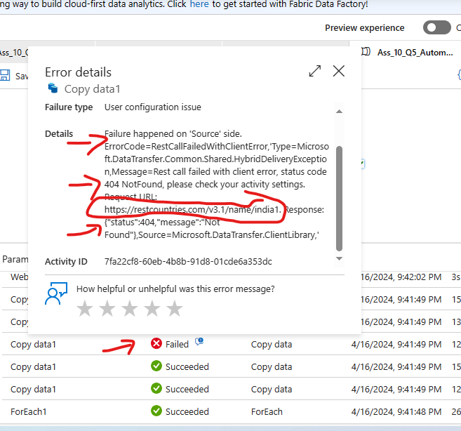

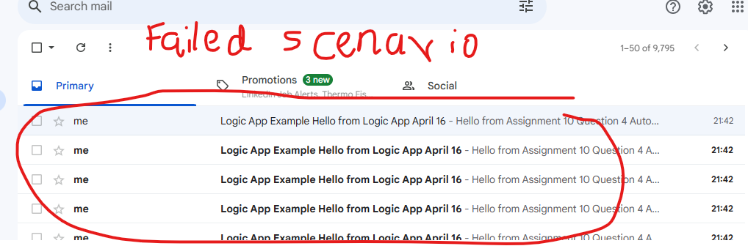

Question 6

6. Once a file for India gets generated trigger a pipeline that will copy the India.json file as CSV into the ADLS account

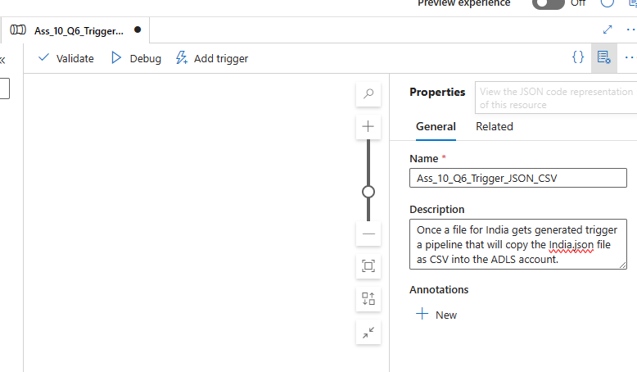

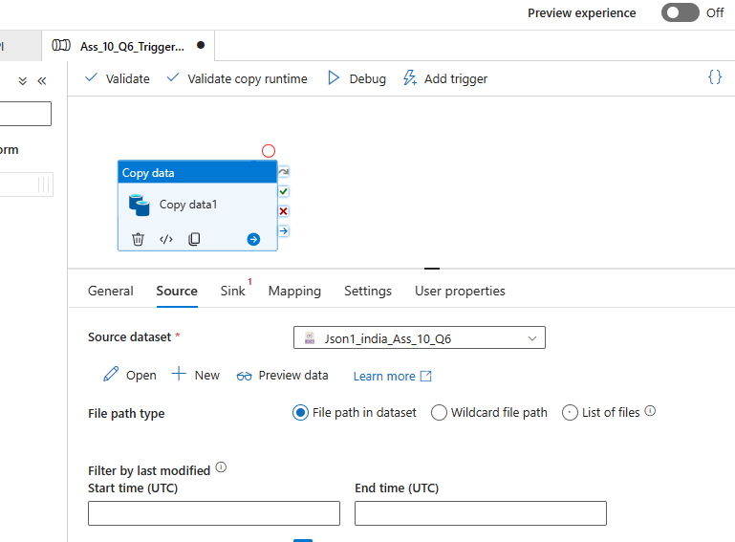

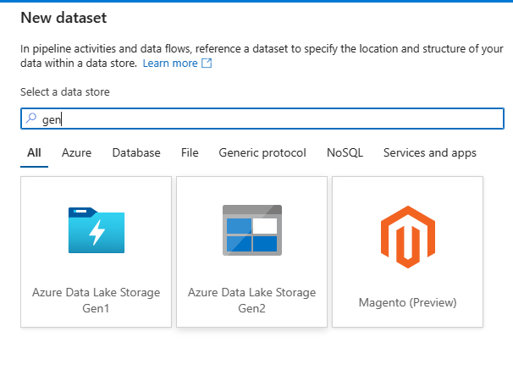

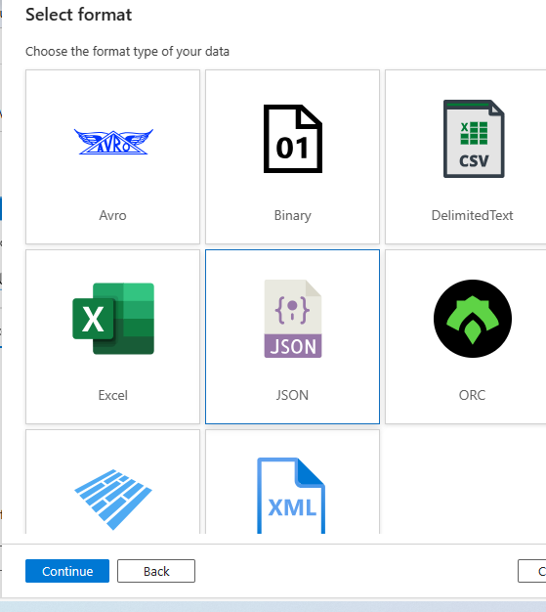

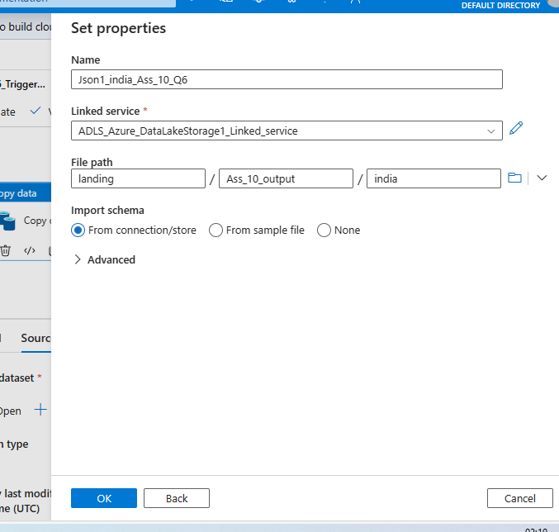

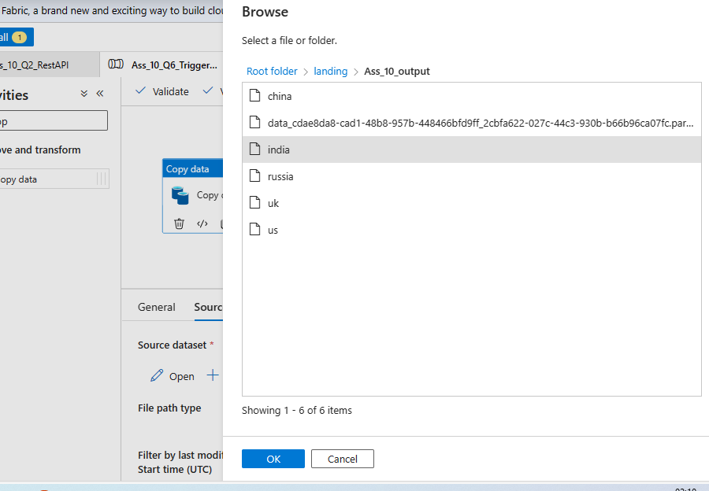

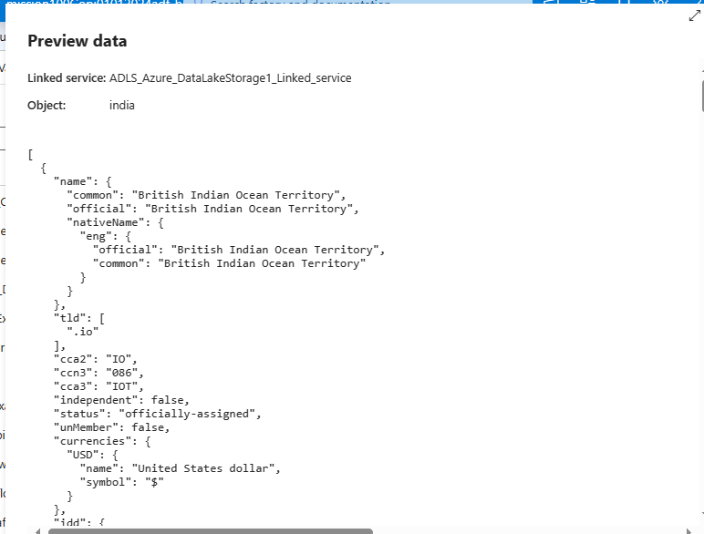
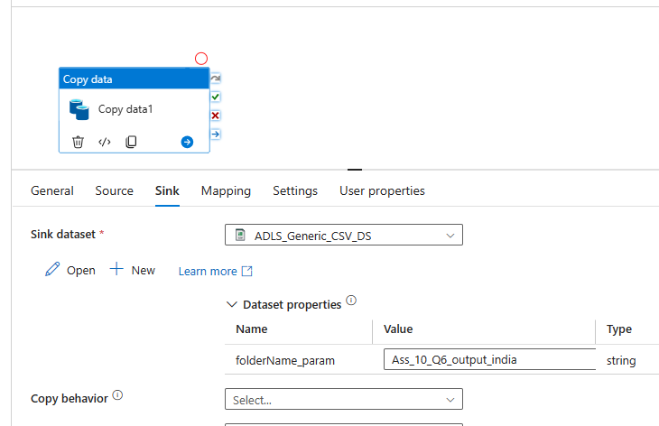

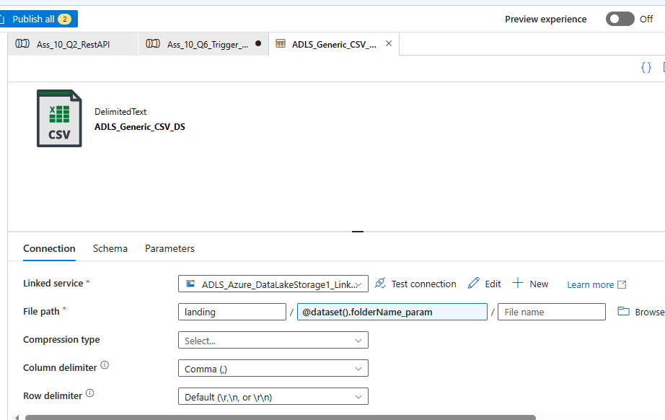

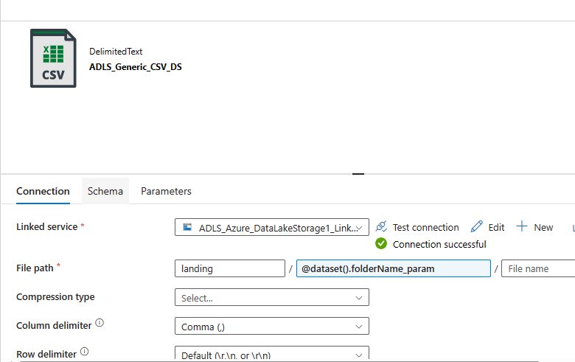

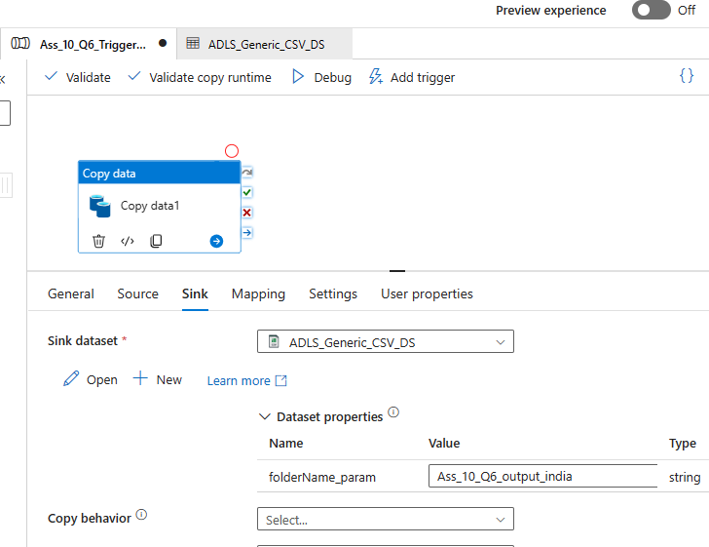

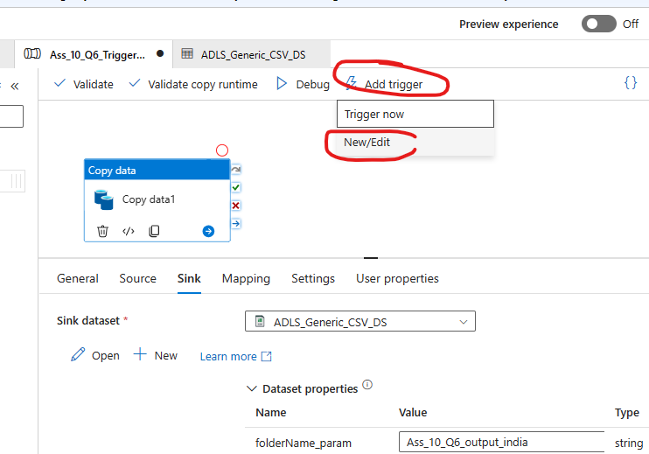

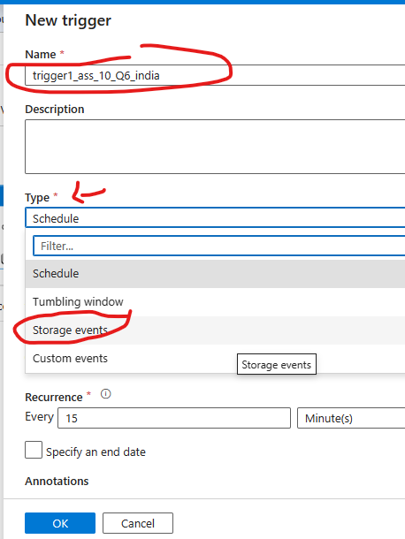

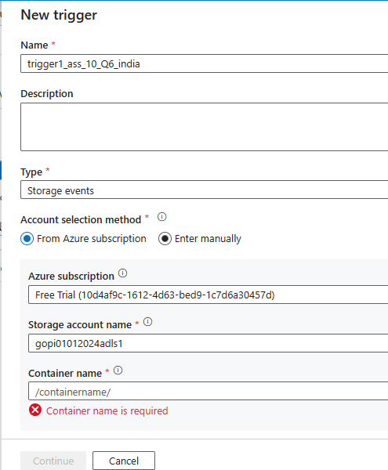

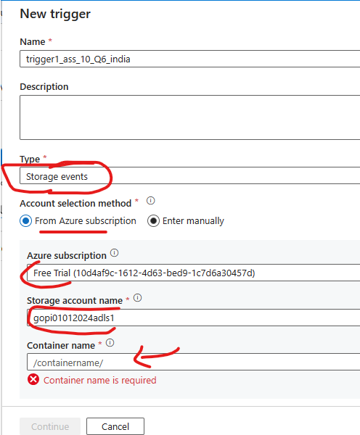

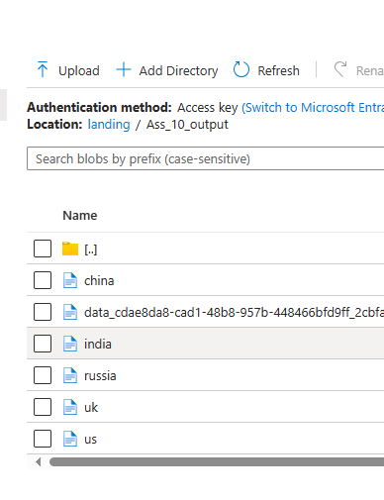

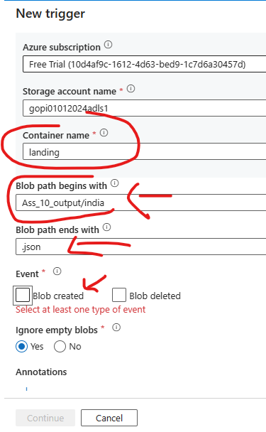

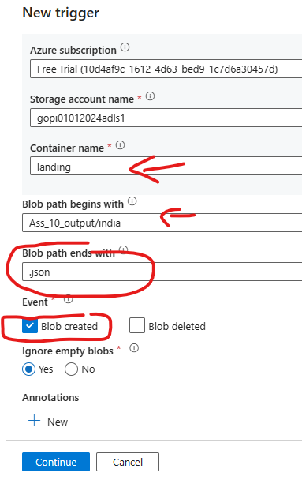

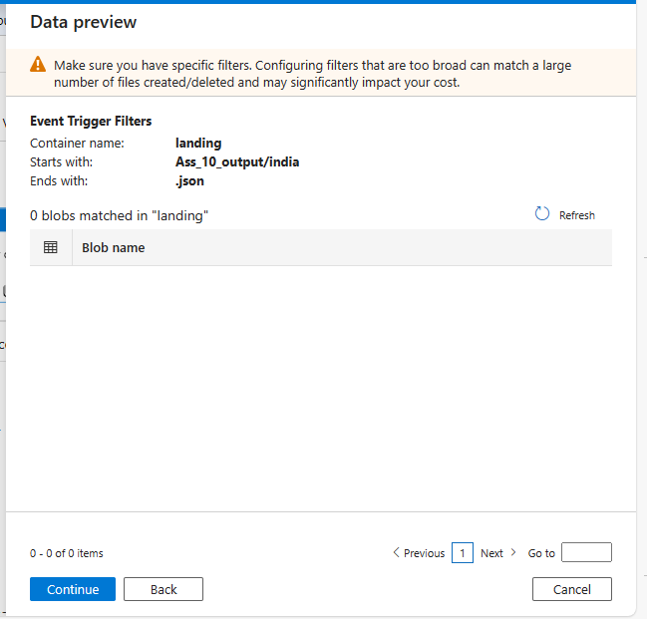
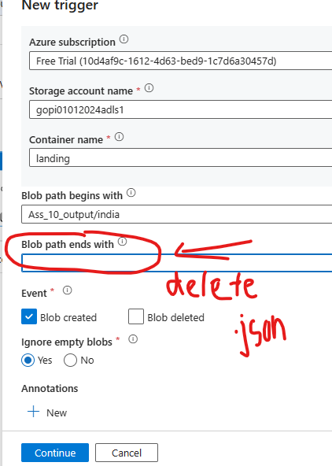

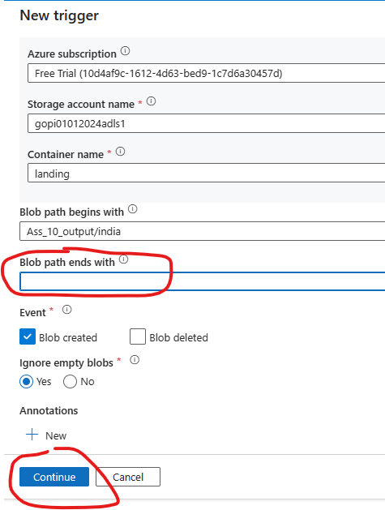

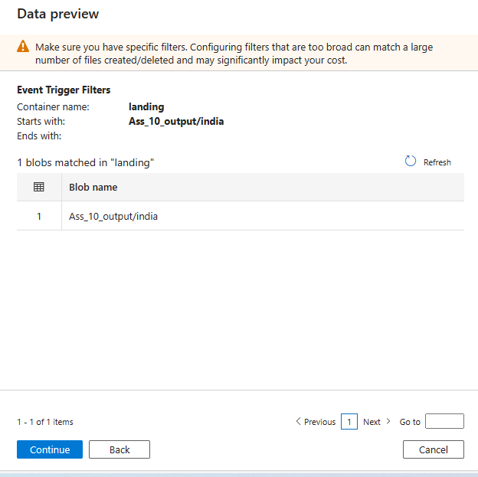

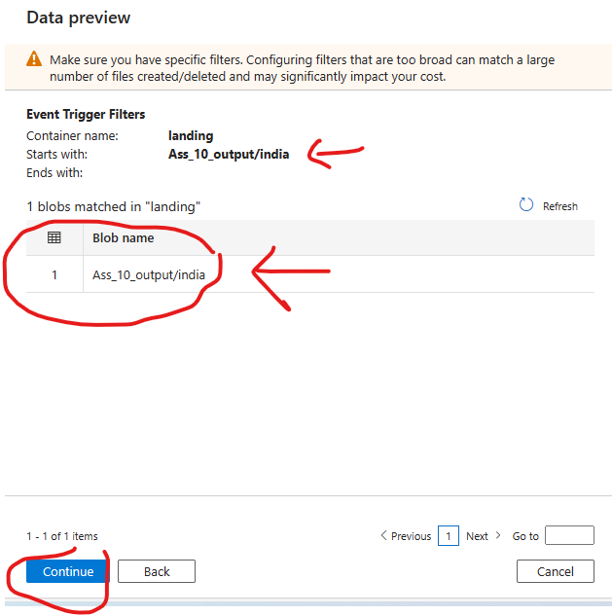

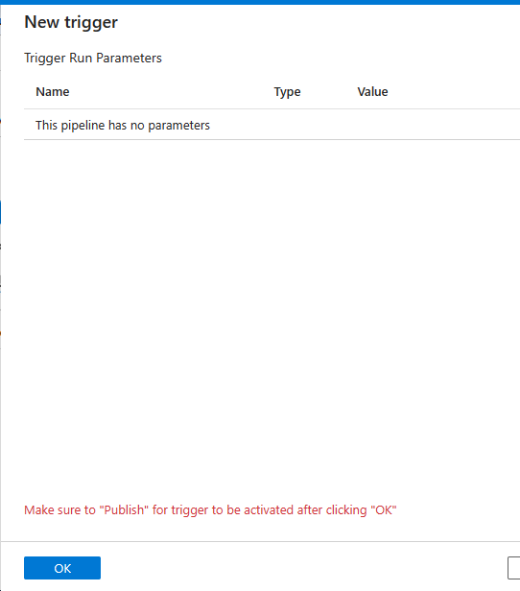

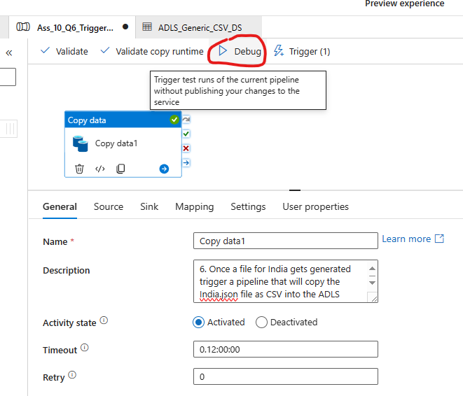

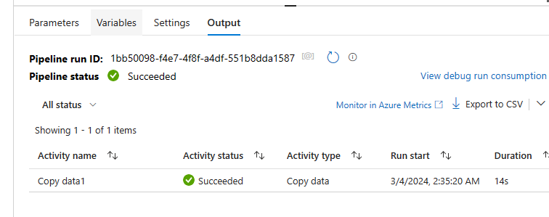
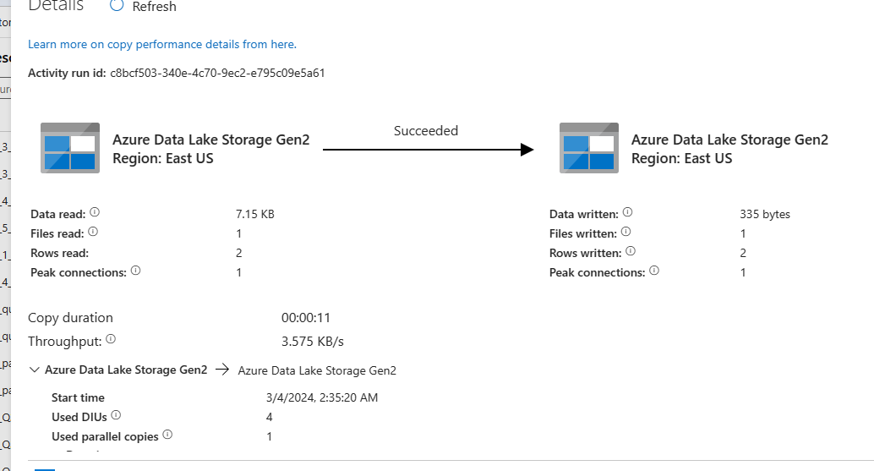

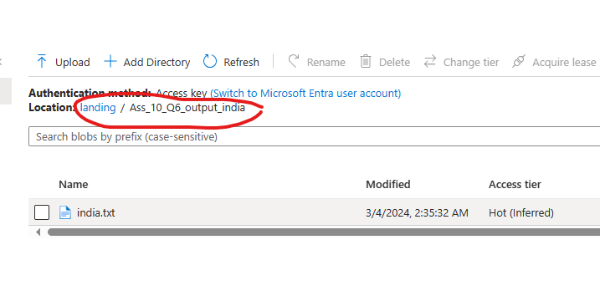
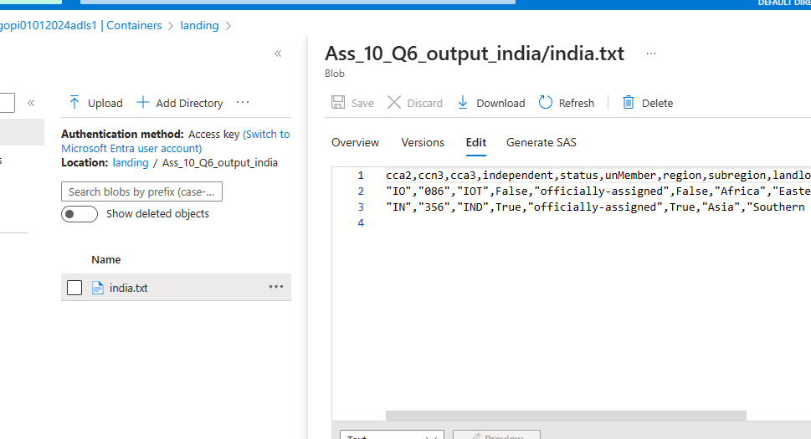

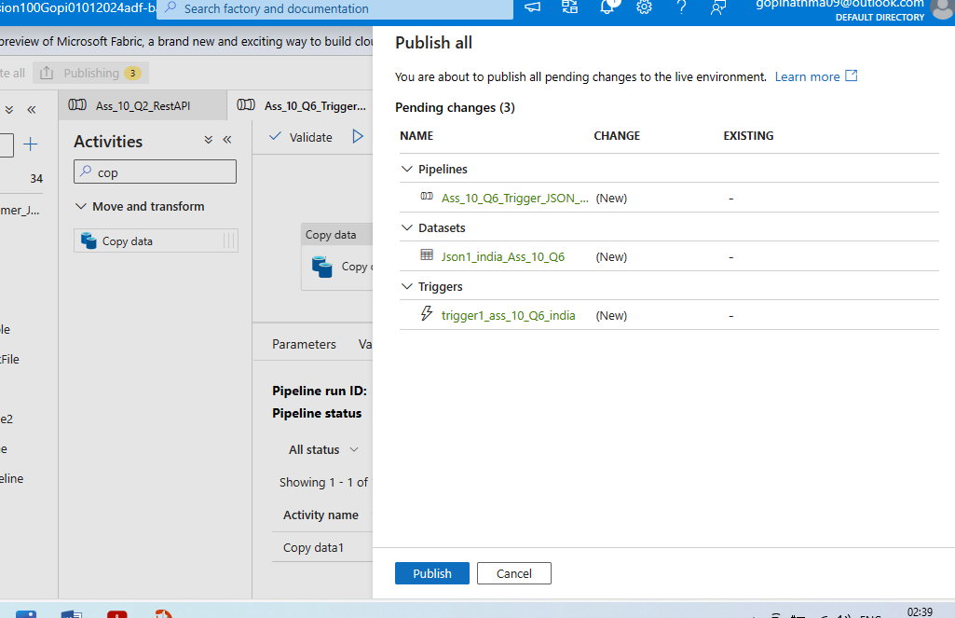

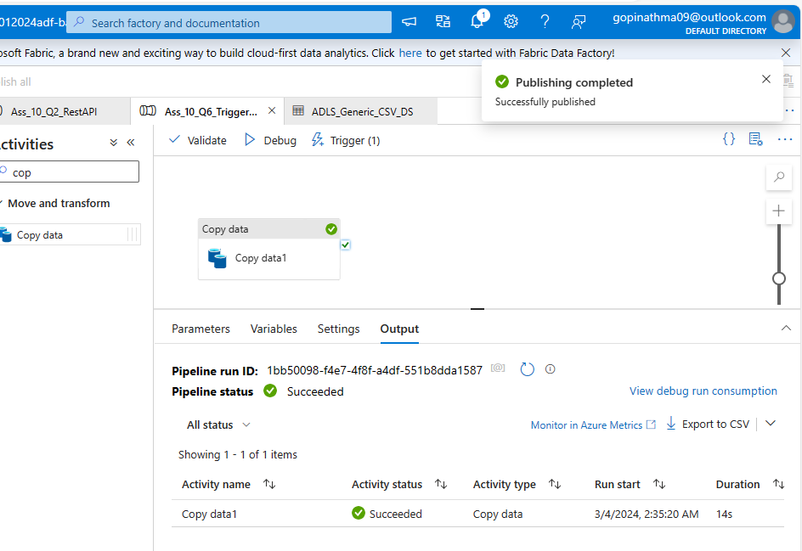

Additional notes:
Steps to complete Assignment 10 using Azure Data Factory (ADF) and related Azure services.

Step 1: Fetch All Countries Data
- Create Linked Services:
  - Create a linked service to connect to the REST API.
  - Create a linked service to connect to Azure Data Lake Storage (ADLS).
- Create a Data Pipeline:
  - Go to your Azure Data Factory.
  - Create a new pipeline.
  - Add a Copy Activity to fetch data from the REST API.
  - Configure the Source to use the REST API linked service with the URL https://restcountries.com/v3.1/all.
  - Configure the Sink to save the data as a Parquet file in ADLS.
- Publish and Trigger the Pipeline:
  - Save and publish the pipeline.
  - Trigger the pipeline manually to ensure it works correctly.

Step 2: Fetch Data for Specific Countries
- Create Parameters in the Pipeline:
  - Create parameters for the country names (e.g., @pipeline().parameters.countryName).
- Add Activities for Each Country:
  - Create a Copy Activity for each of the 5 countries.
  - Configure the Source to use the REST API linked service with a dynamic URL using the parameter (e.g., https://restcountries.com/v3.1/name/@{pipeline().parameters.countryName}).
  - Configure the Sink to save each response as a JSON file in ADLS, with the filename equal to the country name (e.g., @{pipeline().parameters.countryName}.json).
- Loop Over Countries:
  - Use a ForEach Activity to loop over a list of country names (['india', 'us', 'uk', 'china', 'russia']).
- Publish and Trigger the Pipeline:
  - Save and publish the pipeline.
  - Trigger the pipeline manually to ensure it works correctly.

Step 3: Add Scheduled Triggers
- Create a Trigger:
  - Go to the Triggers tab in Azure Data Factory.
  - Create a new trigger that runs at 12:00 AM and 12:00 PM IST.
- Attach Trigger to Pipeline:
  - Attach the trigger to your pipeline.

Step 4: Add Failure Notification
- Add an Email Activity:
  - Add an Azure Function Activity or Logic App Activity to send an email.
  - Create an Azure Function or Logic App to handle the email sending.
- Configure Failure Handling:
  - Configure the pipeline to use the email activity as a failure handler for the Copy Activities.

Step 5: Send Email on Success and Failure
- Add Email Activities for Success:
  - Add another email activity to send success notifications.
  - Configure the pipeline to send success emails after the Copy Activities complete successfully.
- Include Dynamic Content:
  - Use dynamic content to include the Pipeline name, Status, SenderMailID, and Name in the email body.

Step 6: Trigger Pipeline on File Generation
- Create a Trigger for File Generation:
  - Create a trigger based on the creation of the India.json file in ADLS.
- Create a Dependent Pipeline:
  - Create a new pipeline to convert India.json to CSV.
  - Use a Copy Activity to copy the JSON file to a CSV file.
- Attach Trigger to Pipeline:
  - Attach the trigger to the dependent pipeline.

+---------------------+ +---------------------+
| REST API | | ADLS |
| (https://restcountries.com/v3.1/all) |----------->| (Save as Parquet) |
+---------------------+ +---------------------+
\ / \
\ / \
\ / \
\ / \
\ / \
\ / \
v v v
+---------------------+ +---------------------+ +---------------------+
| REST API for Country | | REST API for Country | | REST API for Country |
| (https://restcountries.com/v3.1/name/us) | | (https://restcountries.com/v3.1/name/india) | | (https://restcountries.com/v3.1/name/uk) |
+---------------------+ +---------------------+ +---------------------+
| | |
v v v
+-------------------------+ +-------------------------+ +-------------------------+
| Save as JSON (us.json) | | Save as JSON (india.json)| | Save as JSON (uk.json) |
+-------------------------+ +-------------------------+ +-------------------------+
\ / /
\ / /
\ / /
v v v
+-------------------------------------------------------------+
| Send Notification Email |
+-------------------------------------------------------------+
\ /
\ /
\ /
v v
+-------------------------------------------------------+
| Convert india.json to CSV and Save to ADLS |
+-------------------------------------------------------+

